**ACCOUNTING AND BUSINESS DEPARTMENT**

**FACULTY OF HUMANITIES, MANAGEMENT AND SOCIAL SCIENCES.**

**FEDERAL UNIVERSITY KASHERE, GOMBE STATE.**

**LECTURE MANUAL**

**ON**

**ACC 1302 PRINCIPLES OF ACCOUNTING 11**

**BY**

**UMAR ARDO USMAN (M.Sc, B.Sc, CNA, ANIM)**

**INTRODUCTION**

This course (Principles of Accounting 11) is designed to expose students to the basic foundational aspect of accounting. Therefore, students are expected to pay desired attention in order to have good understanding of the course specifically and the Accounting profession generally.

It is pertinent to know that principles of accounting 11 cover many areas, however, the course will focused on preparation of manufacturing Accounts, Partnership Accounts, Accounts from incomplete record, Receipts and payments, Income and Expenditure accounts among others.

Lastly but not the least is the introduction of company accounts where issue of shares and the attributed terminologies there in would be discussed.

**Performance Objectives.**

At the end of the course students should be able to:

► Prepare Manufacturing, Trading, Profit and loss account and Balance sheet.

► Identify components of prime cost (Direct material, Direct labour and Direct expenses.

► Prepare Partnership Accounts.

► Prepare Account from incomplete record.

► Prepare Receipt and payment Accounts.

► Prepare income and expenditure accounts

► Prepare company accounts and have good understanding of the terminologies there in.

**MANUFACTURING ACCOUNTS**

**Learning objectives**

At the of the chapter, students should be able to explain the following:

**→** Prime cost and items such as (Direct material, Direct labour and Direct expenses)

**→** Overhead cost (indirect expenses)

**→** Work in progress

**→** Cost of production

**→ I**dentify the items that make up the manufacturing accounts to trading accounts

**→** Prepare Manufacturing accounts

**→** Relate Manufacturing accounts to trading accounts

**→** Prepare a balance sheet

**INTRODUCTION**

Manufacturing Accounts

The word manufacturing in this context is the transformation of raw materials into finished goods. In other words, manufacturing is the process of converting acquired raw material into a completed products.

In precise and concise manner, manufacturing accounts is the account prepare to ascertain the cost of production. It is an extension of the trading profit and loss that were dealt with in the previous discussion. While others merely sell products which are acquired in a finished form, some firms, have to manufacture their products before they are sold to the public e.g coca cola, Rekitt benkiser, Nestle, Dangote, Cadbury among others.

**Purpose of Manufacturing Accounts.**

The main purpose of manufacturing accounts can be narrowed to:

1 Ascertained the cost of the goods manufactured

2 Ascertained the amount of any profit on the manufacturing process.

**Division of Cost**

1 Prime cost (consist of Direct materials, Direct Labour and Direct Expenses)

2 Production cost (prime cost+indirect manufacturing cost)

3 Total cost (prime cost+indirect epenses+Administration expenses+ selling & distribution expenses+ finance charge)

**Prime cost:** Theseare cost that can be traced to a particular production units. They however directly related to the manufacturing process such as:

* Direct material
* Direct labour
* Direct expenses
* Other direct expenses

**Direct materials:** This is the expenditure incurred on raw material which can be traced to a particular production units e.g orange in Fanta making.

**Direct labour:** This is the wages of employees who are directly engaged in the production process e.g wages of machine operator

**Direct expenses:** This is the expenses which have direct identification with production for instance royalties.

**Factory overheads:** These are expenditure which cannot be traced to a particular production units but are incurred in relation to the running of the factory. These cost are popularly known as indirect expenses examples are: Factory rent and rates, Depreciation of plant and machinery, indirect wages, upkeep of a factory building among others.

**Production cost:** This is the combination of prime cost and factory overheads.

**Total cost:** This is the overral cost obtained as a result of the summation of (prime cost+production cost+Admin+ selling & distribution expenses).

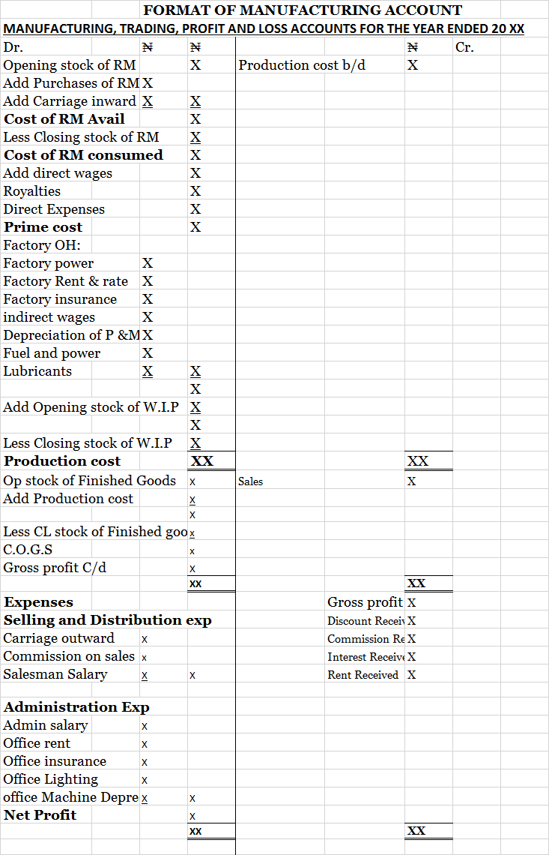

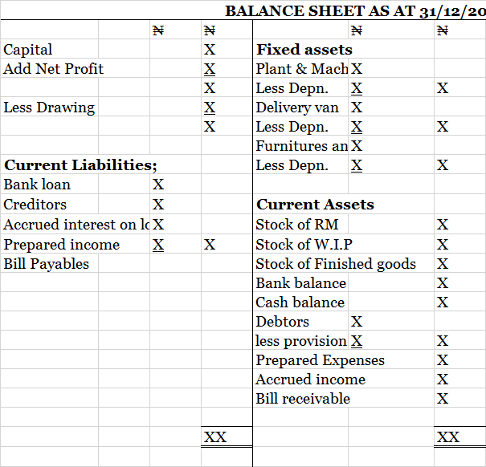

**ILLUSTRATION 1**

GASHULEA LTD are manufacturers and the following balances were taken from the books of the company for the year ended 31/12/2007.

Sundry debtors 12,650

Sundry creditors 9, 820

Purchase of raw material 29,470

Factory Lighting & cooling 2,885

Bank balance 71,316

Stock on 1/1/2007

Raw material 5,360

W.I.P 4,972

Finished goods 16,295

Factory insurance 1,820

Rent 21,600

Cash in hand 3,751

Capital 296,180

Office insurance 550

Sales of finished goods 141,661

Drawings 2,500

Returns on Raw material 1,373

Bad debts 729

Stationery 1,586

Plant and machinery 225,066

Returns of finished goods 1,493

Provision for bad debt 308

Factory wages 13,582

Stock on 31/12/2007:

Raw material 8,619

W.I.P 3,664

Finished goods 11,570

Furniture 38,420

Selling and admin 2,174

Office electricity 1,569

Bank loan 75,000

Office salaries 9,629

Delivery van 56,925

The following additional information is given

1. Interest is due on the bank loan at 5%
2. One third of the rent is to be allocated to the factory
3. Provision for bad debt is to be 2% of the debtors
4. Depreciation is to be written off the plant and machinery at 21/2 % and 5% on delivery van and furniture and fittings

You are required to:

I Prepare manufacturing, trading, profit and loss accounts for the year ended 31/12/2007

II Prepare the balance sheet as at that date.

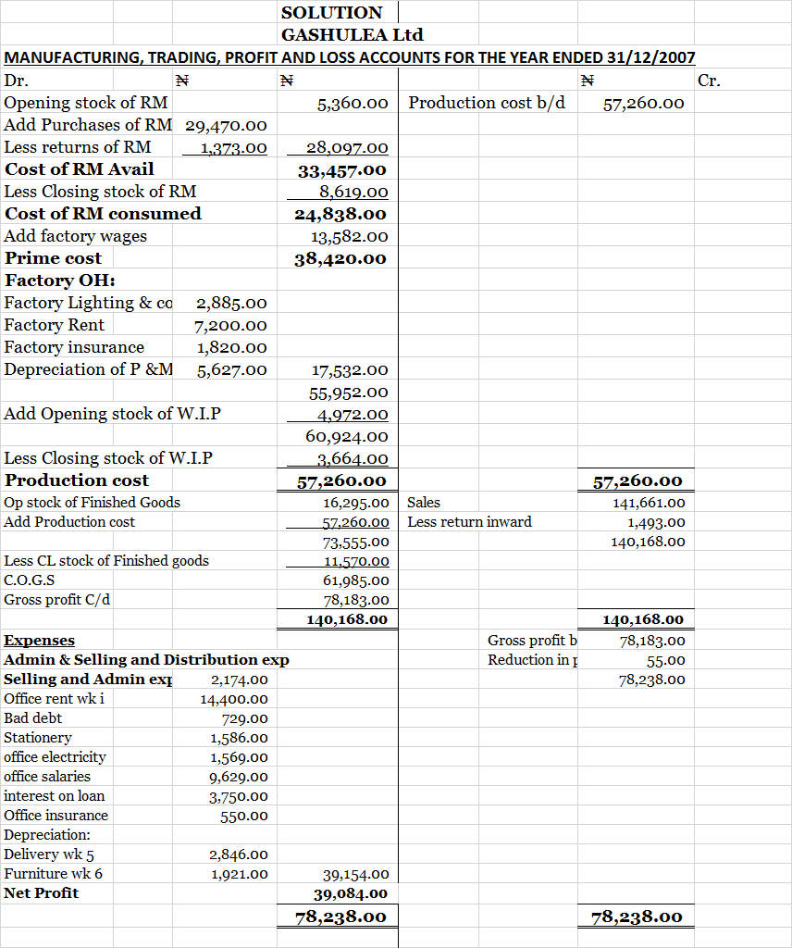





**ILLUSTRATION 2**

**2)** From the following details, you are required to prepare a manufacturing account for the year ended 31/12/2002.

Stock as @ 1/1/2002: ₦

Raw material 5,000

W.I.P 3,000

Stock of finished goods 7,000

Purchases of raw materials 50,000

Manufacturing wages 15,000

Royalties 300

Lubricant 600

Carriage inward of RM material 1,000

Fuel & power 170

Factory insurance 250

Depreciation:

Plant & machinery 1,750

Delivery van 250

Office equipment 300

Advertisement 1,050

Salesman commission 60

Sales 150,000

Delivery van expenses 120

Stock as @ 31/12/2002:

Raw material 4,500

W.I.P 2,030

Stock of finished goods 4,600

**SOLUTION**



**COMPANY ACCOUNTS**

**PERFORMANCE OBJECTIVES.**

By the end of the lecture students should be able to:

* Define Company.
* Explain the use of profit and loss appropriation accounts and also identify items in the profit and loss appropriation accounts
* Explain the various kind of companies such as: Unlimited Company, limited by shares and limited by guarantee.
* Explain how a company is form.
* Explain the types of companies
* Explain some terminologies such as bonus issues, revenue reserve, right issue, prospectus, share at par, share issued at discount and at premium, working capital, others are capital reserve, capital employed, loan capital, quoted and unquoted companies, preference shares, ordinary shares and debentures to mention but a few.

**INTRODUCTION**

It is worthy to note that company Account is a topic that has covered significant aspect of company formation, operation and its final Accounts. Students are expected to pay desired attention in order to have sound and solid background.

**COMPANY**: Company can be defined in various ways According to their perception or views. However, it is simply a business owned by an association of people and operated as a legal person on behalf of its owners with a view of making profit for instance; Dangote group, Nestle plc etc.

**Kinds of Companies**

According to company Act, there are three kinds of companies which may be constituted or incorporated these are:

1. Unlimited companies: In this company, the liability of the members for the debt of the company is unlimited.
2. Company limited by shares: Under this company their liabilities is limited to amount invested in the business (i.e limited to the shares)
3. Company limited by guarantee: These are companies whose liabilities is limited to the amount guaranteed by the members in the event of liquidation e.g club.

Limited companies are so popular compared with partnership business. Limited companies enable larger businesses to be formed, and help an owner safeguard his private assets. The owners’ (shareholders’) loss is only limited to the amount of shares they bought.

**Characteristics of limited companies**

1. Legal entity.
2. Limited liabilities.
3. Perpetual existence.
4. It is authorized by law to carry on a specific line of business.

**Types of companies**

It is instructive to note that limited liability companies have profit as their motive of operation. However, these limited liability companies can be classified into two main types which are:

1. Private limited liability
2. Public limited liability.

Private limited liability companies these are company with members not exceeding fifty persons and its shares can neither be offered to the public for subscription nor transferred such shares. Moreover, these companies end their names with LTD. While

Public limited liability companies are those companies with at least minimum of seven members and has no maximum number of owners. Its shares is listed on the Nigerian stock exchange and can issued shares to the general public for subscription. In addition, it can transfer its shares and their name end with PLC.

Preparation and presentation of financial statements to comply with standard international accounting practice.

**Published Accounts of Quoted Companies**

The Trading Account of a Limited Liability Company is the same as any other business. However, the profit and loss account of a limited liability company contains items which would not normally be found in the profit and loss account of a Sole Trader or a Partnership. These items are: Directors fees and salaries, Interest on debentures, Auditors fees, Taxation.

Public Financial Statements include the following:

1. Chairman’s Report

2. Director’s Report

3. Auditor’s Report

4. Audit Committee’s Report

5. Statement of Accounting Policies.

6. Notes to the Accounts

7. Income Statements

8. Balance sheet

9. Cash flow statement

10. Value added statement

11. Five year financial summary

In this module we will consider several terminologies under company accounts which include company formation, issues and redemption of shares, types of shares- ordinary shares, preference shares, deferred founders shares. Others are: Authorized shares, Issued shares, called up shares, uncalled up share, Paid up shares, unpaid up shares, Prospectus etc.

**ACCOUNTING FOR COMPANIES FORMATION**

**ISSUES AND REDEMPTION OF SHARES**

Shares are securities evidencing ownership interest in a company. They are the small units, each of equal amounts, into which the capital of a company is divided.

**Types of Shares**

**Ordinary Shares:** These are shares whose holders receive dividend only after the preference shareholders have received dividend. They are regarded as the risk bearer because they bear the heaviest loss in the event of liquidation of the company.

**Preference Shares:** These are shares which have the following characteristics:

•Their holders receive dividends at specified rates.

•Their holders receive dividends ahead of ordinary shareholders; and

•Their holders are not entitled to partake in the surplus in liquidation unless the Articles of Association stipulate otherwise.

**Deferred Founders’ Shares:** The holders of the shares are not entitled to receive dividends until the ordinary shareholders have received dividends. They are however entitled, like the other classes of shareholders, to attend and vote at the Annual General Meeting.

**Prospectus:** This is a document that contain full details of how the offer of subscription is to be made. It disclose the number of shares to be issued and issue price, it further details the amount to be paid on Application and allotment, First, second and final calls etc.

**Authorized shares capital:** This is the maximum limit of shares that a company can offer. In other words, it is the registered number of shares.

**Issued shares capital:** This is the total number of shares that the board of directors resolved to offer to the general public for subscription. It is simply number of shares for sale out of the authorized shares capital.

**Called up shares capital:** It is the number of shares that the potential shareholder declare interest on or call for. Mostly, called up shares are slightly below the issued shares however, it can be equal to the issued share if the company has good going concern.

**Uncalled up shares capital:** This is the portion of the issued shares that the public have not declared interest.

**Paid up shares capital:** Paid up capital is the portion of the called up capital that the subscriber committed themselves financially by paying for the shares.

**Unpaid up shares capital:** Itis the remaining part of the called up shares that the subscriber have not yet paid for.

**Illustration 1**

**Issues of share at par**

BAKKO plc has an authorized ordinary share capital of 10,000,000 of N3 each. On January 2, 2006 public subscription/offer was made for 2,000,000 ordinary shares payable as follows:

On application 1.20

On allotment 1.40

First call 0.20

Second and final call 0.20

3.00

All monies were collected as at when due.

**Required:**

Open necessary ledger to record the above transactions.

Show the balance sheet extract after completing the transactions.

**SOLUTION**

**BAKKO Limited**





**Illustration 2**

**Issues of Shares at a Discount**

ASMAU plc has made application to public to subscribe for 5,000,000 Share of N10 each at N8 payable as follows:

On Application 2.00

On Allotment 1.00

First call 3.00

And the balance is to be paid on 2nd and Final call is 2.00

All monies due were received at the right time.

**Required:**

Prepare relevant ledger to record the above transactions.

Show the balance sheet extract.

**SOLUTION**

**ASMAU Limited**





**ILLUSTRATION 111**

**Calls in Arrears and Calls in Advance**

ZELEEZU Investment Ltd. offered for application to the public 4,000,000 ordinary shares of N100 each at par payable as follows:

On Application N30.00

On Allotment (including premium) N20.00

1st Call N35.00

2nd & Final Calls N15.00

All monies were dully received except for holders of 500,000 shares who refused to pay the amount due on first call. Holders of 300,000 shares paid for the 2nd and final call alongside with amount due on first call.

**Required:**

1. Prepare relevant ledger to record the above transactions.

2. Show the balance sheet extract.

3. Journalize the above transactions

**SOLUTION**

**ZELEEZU Investment.**





**SINGLE ENTRY AND INCOMPLETE RECORD**

**Learning objectives**

At the end of the module, readers should be able to:

1. Explain single entry (incomplete record).
2. Identify the limitation of single entry.
3. Convert single entry to double entry
4. Prepare statement of affairs
5. Determine capital and profit.

**Introduction**

It is instructive to know that sound and adequate knowledge of double entry principles and control account will go a long way in tackling problems related to single entry and incomplete record. Single entry is a system of book keeping which does not conform to the basic principles of double entry, since account are normally kept in a double entry aspect, thus, any system which ignores this two-fold aspect is known as single entry.

In nutshell, single entry or incomplete record is a record prepared and kept by the bookkeeper which are; inadequate, incomplete, inaccurate and insufficient that the accountant need to use his professional competency to prepare the account from such available information.

**Features of single entry.**

1. The profit or loss could be ascertained by comparing the closing and opening capital.
2. Real and nominal account are not kept except the personal account
3. Only personal accounts of debtors and creditors are kept.
4. There is need to prepare an opening statement of affairs to ascertain the opening capital
5. There is also need to prepare closing statement of affairs to ascertain the closing capital.

**Disadvantages**

IIt does not conform to the principles of double entry.

II The flexibility of the double entry principles is lacking.

III It is difficult to obtain accurate information since the record are not complete.

IV It is difficult to arrives at the profit for the year

V Fraud may be easily committed

VI It is not possible to ascertain the arithmetical accuracy of the books.

**Computation of profit from two Balance sheets.**

It is not unknown that under single entry system, the record are incomplete, the assets and liabilities are given but information relating to sales and purchases are not given.

The profit or loss can be ascertained by comparing the value of opening capital and closing capital. Here, the statement of affairs method will be adopted to take care of the insufficient information.

**Book-keeping rule for single entry**

1. The opening statement of affairs will be prepared to show the opening capital. The information required are: all fixed assets, total of debtors and creditors, expenses owing and payment in advance, cash and bank balance etc.
2. Adjust the capital by adding any additional capital contributed either in cash or assets and deduct drawing either cash or goods.
3. Another statement of affairs will be constructed to show the closing capital using all the assets and liabilities at the end of the period.
4. The opening capital will be compared with the closing capital.
5. If the capital at close is greater then there is a profit
6. While if the capital at close is lower then there is a loss.





On 31st December 2006, the following were the ledger balances: creditors ₦1,500, bill payable ₦800, plant and equipment ₦2,500, stock ₦500, debtors ₦1000, bill receivable ₦700, cash ₦10. Drawing amounted to ₦800.

Required to: Prepare the statement of affairs to show the closing capital and the net profit respectively.

**SOLUTION**

**Step 1**

Prepare the statement of affairs to show the opening capital.



**Step 11**

Prepare the statement of affairs to show the closing capital.



**Step 111**

Calculate the Net profit

Lakuniya enterprise

Statement of profit for the year ended 31/12/2006

|  |  |  |  |
| --- | --- | --- | --- |
|  |  | ₦ | ₦ |
| Closing capital | |  | 2410 |
| Add drawing | |  | 800 |
|  |  |  | 3210 |
| Less Opening capital | |  | 3000 |
| **Net Profit/Loss** | |  | **210** |
|  |  |  |  |

**PREPARATION OF FINAL ACCOUNTS FROM A SET OF INCOMPLETE RECORD.**

**CONVERSION OF SINGLE ENTRY TO DOUBLE ENTRY.**

Business organisation whose books are being kept under the single entry system may decide to improve the system of accounting by introducing a complete double entry system. However, the following books may be necessary:

1. Sales ledger
2. Purchase ledger
3. Day book
4. Cash book
5. Assets and liabilities account
6. Nominal accounts.

The trial balance may be extracted to show the accuracy of the posting there are no specific set of rules to be followed except a proper understanding of the principles of double entry.

**Accounting entries**

In preparing final accounts from incomplete records, the following operations must be followed.

1. Preparation of a statement of affairs to calculate the capital

2. Analysis of the cash book

3. Reconstruct those accounts that are necessary to find figure not given in the question.

Analysis of both purchase and sales control to get purchase and sales respectively.

4. Preparation of any other required working schedule e.g reconstruction of nominal accounts.

5. Preparation of trading profit and loss account.

6. Balance sheet.

**Illustration 2**

The following is the summary of cash book of Jegede for the year ended 31st March 1995



Additional information.

1/4/94 31/3/95

₦ ₦

Stock 5,600 3,400

Debtors 12,020 9,880

Creditors 9,800 10,510

Accrued salaries 4,200 750

Prepared rent 440 670

You are required to prepare:

1. Statement of affairs as at 1/4/94
2. Debtors and creditors control accounts.
3. Trading profit and loss accounts
4. Balance sheet as at 31/3/95

**SOLUTION**

1. Statement of affairs will be prepared to show the opening capital

Jegede Books



1. The total control Account will be used to calculate the sales and Purchases





1. After we have the values of sales and purchases, the next step is to prepare the final Accounts





WORKINGS ₦

1. Salaries 10,800

Add owing 1995 750

11,550

Less owing 1994 (4,200)

P&L 7,350

1. Rent 5,700

Prepaid 1994 440

6,140

Less prepaid 1995 670

P&L **5,470**

**ACCOUNTING FOR NON-PROFIT MAKING ORGANIZATION**

**Learning Objectives.**

At the end of the module, students should be able to:

►Explain the following terminologies;-

* Surplus
* Deficit
* Subscription
* Accumulated fund
* Subscription in arrears and subscription in advance
* Receipt and payment
* Income and expenditure
* Distinguish between ‘’Receipt and payment’’ and ‘’income and expenditure’’
* Prepare Receipt and payment Account
* Prepare income and expenditure Account
* Prepare statement of affairs at start.
* Prepare a balance sheet.

**INTRODUCTION**

It is generally known that commercial and industrial companies are set up principally to make profit, however, Non-profit making organizations like clubs, socities and charitable bodies are not profit oriented rather to provide services to their members. Their aim is not to make profit but to facilitate the attainment of certain objectives which may be social or political, religious, educational or developmental. These organization prepare Receipt and payment, Income and expenditure and balance sheet instead of Trading, profit or loss account for the year ended.

**Sources of income for non-profit organizations**

1. Members’ subscriptions
2. Fine on erring members
3. Donations
4. Special events such as annual fete, annual dinner dance, raffle draw etc.
5. Profit from bar.
6. Profit from disposal of assets.
7. Interest from investment
8. Proceed from rentals
9. Life membership due
10. Gift
11. Government subvention.

**Differences between profit-oriented organizations and non-profit oriented organization are summarized in a tabular form as can be seen below.**

|  |  |  |
| --- | --- | --- |
| **S/NO** | **PROFIT-ORIENTED ORGANIZATION** | **NON.PROFIT ORIENTED ORGANIZATIONS** |
| **1** | Profit & loss | Income & expenditure account |
| **2** | Net profit | ‘’Surplus’’or excess of income over expenditure |
| **3** | Net loss | ‘’Deficit’’ or excess of expenditure over income |
| **4** | capital | Accumulated fund |
| **5** | Trading account | Bar trading account |
| **6** | Gross profit | Bar profit |
| **7** | The main objective is to maximize profit | No profit motive |

**RECEIPT AND PAYMENT**

It is pertinent to know that this is the account that shows the summary of the cash book over a particular period of time. Under this, capital receipts and payments, revenue receipts and payments are included and it follows the same principle as the cash book. All accruals and prepayments are not shown in the receipts and payments.

**Features**

1. Items are treated in the same way as cash book.
2. All receipts and payments are recorded.
3. Amount owing or prepaid is not shown.
4. It is a real account.
5. It is a prime book
6. It has opening and closing balances.
7. It record both capital and revenue transactions.
8. Its closing balance is transferred to balance sheets.
9. Its records are supported by source documents
10. It is used by not for profit making organization.

**Limitation of Receipts and payments**

1. There is no figure for net income or net expenditure.
2. It is not a useful guide as to whether the organization is paying its way.
3. Lack of comparability.
4. It does not disclose profit or loss on disposal of fixed assets.
5. Non cash items like bad debt and depreciation are not disclosed.
6. Accruals and prepayments are not disclosed too.

**FORMAT OF RECEIPTS AND PAYMENTS ACCOUNT**



**INCOME AND EXPENDITURE ACCOUNTS**

This is an account that is prepared based on the same principle as the profit and loss accounts. In nutshell, it is described as the equivalent of a profit and loss account prepared by a trading business.

**Rule for the income and expenditure account**

* Expenses are debited and income are credited.
* Capital items are excluded
* All revenue items relating to the period are credited, whether actually received or not.
* All expenditure items relating to the period are debited, whether actually paid or not.
* All items relating to the previous or next period are excluded.
* The balance on the account represents the excess of income over expenditure or vice versa.

**Features of Income and Expenditure Account**

* It is a nominal account
* It is prepared in the form of profit and loss
* It records revenue receipts and revenue expenditure
* It allows adjustments for prepayments and accruals
* Its closing balance represents surplus or deficit.
* It is used by not for profit making organization.

**FORMAT OF INCOME AND EXPENDITURE ACCOUNT**



**Differences between Receipt and payment and Income and expenditure account are summarized below.**

|  |  |  |
| --- | --- | --- |
| **S/NO** | **Receipt and payment Account** | **Income and expenditure Account** |
| 1 | Maintained on cash basis i.e expenses are recorded when they are paid and incomes are recorded when they are received | Maintain on accrual basis i.e expenses are recognized when they are incurred and income are recognized when they are earned |
| 2 | Does not include notional charges such as depreciation | Include notional charges such as depreciation |
| 3 | Include payments for capital expenditure and receipt of capital income | Does not include capital expenditure and incomes. |
| 4 | Objective is to ascertained the balance of cash in hand or at bank at year end. | Objective is to ascertained the surplus deficit for the year. |

**Similarities between Receipt and payment and Income and expenditure account are stated below.**

1. Both are prepared on double entry basis.
2. Both are summaries of financial transactions.
3. Both are made to cover the same period to enable balance sheet to balance.

**TERMINOLOGIES ON NON PROFIT MAKING ORGANISATION**

**Accumulated fund:**  This takes the place of capital. It is the excess of assets over liabilities of a non-profit making organisation.

**Subscription:** This is the periodic contribution of members to the association or society. Members are enjoined to pay their subscription as at when due.

**Entrance fee:** This is the money paid by member to join the association.

**Subscription in arrears:** This is a sum of money due from members but remained unpaid. This is treated as debtor in the balance sheet of a non-profit making organisation.

**Subscription in advance:** This is a sum of money paid for future years by members. It is treated as current liabilities items.

It is vital to note that subscription account need to be adjusted before posting to the credit side of the income and expenditure account.

**Donation:** it can be referred to as gift of money or goods from any member or outsiders to the club.

**Surplus:** This is excess of income over expenditure

**Deficit:** This is excess of expenditure over income.

**Receipts:** The amount that is coming into the organisation.

**Payments:** This is the amount that is going out of an organisation.

**Income**: Money one earns by working or by capitalizing on the work of others.

**Expenditure:** is the amount spent in order to acquire a commodity or services

Other terminologies are: Bar trading, bar profit, Profit from disposal of fixed assets, Life membership fee, Profit from investment, Secretary honorarium among others.

**ILLUSTRATION 1**

Below is the summary of Receipt and Payment of Young Shall Grow club for the year ended 31st December, 1995 ₦

Balance 1/1/95 48,310

Proceeds from Dance 36,150

Transfer to bank deposit 120,000

Rates 10,000

Entrance fees received 5,000

Wages paid 72,300

Subscriptions received 300,000

Equipment bought 40,000

Repairs 16,172

General expenses 48,896

Stationery bought 9,790

Interest received on bank deposit 12,000

Donation received 4,200

Additional information:

1. Wages of ₦4,800 were due and unpaid at 31st December,1995.
2. Rates prepaid amounted to ₦2,000
3. General expenses include ₦3,000 owing since the previous year.
4. Of the subscription received ₦8,000 was in arrears the previous year while ₦20,000 was paid in advance for coming year, in addition ₦12,000 was still owing at 31st December, 1995.
5. The club had the following properties on 1st January, 1995:

₦

Club house 960,000

Equipment 600,000

Bank deposit 400,000

1. Depreciate club house by 5% and equipment including additions within the year by 10%.

You are required to prepare:

1. Receipt and payment account for the year ended 31st December, 1995
2. Income and expenditure account for the year ended 31st December 1995 and
3. Balance sheet as at that date.

**SOLUTION**











The difference between the assets and the liabilities will give you the Accumulated fund.







**3)** You are required to prepare a Statement of affairs as at 1st January 2006 and Income and expenditure account for the year ended 31st December 2006 from the Receipts and Payment account of Country Club Universal for the year ended 31st December 2006 as stated overleaf: 



**PARTNERSHIP ACCOUNTS**

**Learning objectives**

**By the end of the module, students should be able to:**

* **Define partnership**
* **Explain the term Deed of partnership**
* **Explain various Types of partnership**
* **Prepare partner’s-:**
  + **Final Account**
  + **Appropriation account**
  + **Current and capital account**
  + **Balance sheet.**

**INTRODUCTION**

Partnership has been perceived in different ways by different scholars however, Partnership Act of 1890 gave most popular definition which viewed partnership as a relation which subsists between persons carrying on a business in common with a view to make profit.

It is also vital to note that its members must be at least two and at most twenty members. The partnership agreement guide and regulate the activities of partnership business.

**PARTNERSHIP AGREEMENT**

The partnership Agreement or deed is a formal agreement drawn up to direct, guide and regulate the activities of partnership business. The partnership deed include but not limited to the following:

1. The amount of capital to be contributed by each partner.
2. Whether the capital account are to be fixed, drawing and profit being adjusted on current accounts, or whether the capital accounts are to be fluctuating, drawing and profit being adjusted on capital accounts.
3. The ratio in which profits/losses are to be shared among the partners.
4. The rate at which interest is to be allowed on partner’s capital
5. The amount of salary receivable by partners.
6. The rate at which interest is to be charged on partners’ drawing.
7. The rate of interest to be allowed on partners’ loan.
8. Whether current account, if any, are to bear interest and if so at what rate.
9. The method of calculating goodwill in the event of death, retirement or admission of partners.
10. The method of treating the premium on life insurance policies, if any and how the proceeds of the policies are to be shared among the partners.

In the absence of express or implied agreement to the contrary, the partnership Act 1890 stipulates that the following rules apply, inter alia:

1. Profits/losses be shared equally.
2. Interest shall not be allowed on partners’ capital
3. Interest shall not be charged on partners’ drawings.
4. Interest shall be allowed on partner’s loan at 5% per annum.
5. No partners shall be entitled to receive salary.

**ILLUSTRATION**

Manu, usman and ummi are in partnership business sharing profits and losses in the ratio of 3:2:2 respectively. Below are the details of their operation:

N

Net profit as at 31st December 2000 35,000

**Capital account:**

Manu 20,000

Usman 15,000

Ummi 15,000

**Current Account:**

Manu 3,000

Usman 2,000

Ummi 1,500

Manu, Usman and Ummi’s drawing were N800, N500, and N300 respectively. Manu and Usman are participating in running and management of the business thus, are entitle to a salary of 2000 and 1,500 respectively. Ummi receives 5% interest on loan. The assets and liabilities for the business as at 31st December 2000 are as follow:

N

Furniture N7,050

Building N54,000

Stock N17,500

Debtors N18,500

Creditors N4,000

Loan N3,000

The partners agreed to pay 4% interest on their drawing and 5% interest on

Capital.

**REQUIRED:**

1. Appropriation account
2. Current and capital account
3. Balance sheet

**SOLUTION:**

**WORKINGS**

**(W1) Interest on drawings**

Manu 4/100× N 800 = 32

Usman 4/100× N 500 =20

Ummi 4/100× N300 = 12

**(W2) Interest on capital**

Manu 5/100× N 20,000 = 1,000

Usman 5/100× N15, 000 = 750

Ummi 5/100× N15000 = 750

**(W3) Interest on loan**

Ummi 5/100× 3000 = 150

**DR. APPROPRIATION ACCOUNT CR**

N N N N

Salaries: Net profit 35,000

Manu 2000 Interest on drawing: (W1)

Usman 1,500 3,500 Manu 32

Usman 20

Interest on capital: (W2) Ummi 12 64

Manu 1,000

Usman 750

Ummi 750 2,500

6,000

Shared profit:

Manu 3/7× 29,064 = 12,456

Usman 2/7× 29,064 = 8,304

Ummi 2/7× 29,064 = 8,304 29,064

35,064 35,064

**DR. CURRENT ACCOUNT CR.**

Manu Usman Ummi Manu Usman Ummi

N N N N N N

Drawing 800 500 300 Balance b/d 3,000 2,000 1,500

Interest on drawings 32 20 12 Salaries 2,000 1,500 -

Interest on loan (W3) - - 150

Interest on capital 1,000 750 750

**balance c/d 17,624 12,034 10,392** Shared profit 12,456 8,304 8,304

**18,456 12,554 10,704 18,456 12,554 10704**

**DR. CAPITAL ACCOUNT CR.**

Manu Usman Ummi Manu Usman Ummi

N N N N N N

**Balance c/d 20,000 15,000 15,000 Balance b/d 20,000 15,000 5,00**



**ACC 1302 PRINCIPLS OF ACCOUNTING 11**

**PRACTICING QUIZE QUESTIONS.**

1. The concept that recognized revenue earn and expenses incurred not necessary received cash or paid cash is called?------------
2. Mr ------------- is the father of Accounting.
3. ---------------- is used to adjust fixed assets in an organization that prohibit fixed assets written off at time of purchase.
4. If fixed assets in Government accounting are written off at the time of purchase, it means such asset will not appear in------------.
5. The assumption that business will continue to exist for a long period of time is in accordance with ---------------
6. If Mr Umar paid sanibu ₦20,000 cash as salary for keeping time during lectures, as an accountant, identify the two fold effect.
7. In view of the question 6 above, ‘’which account is to be debited and which one to be credited’’.
8. State why debiting or crediting a particular account in question 7 above.
9. Bad debt are written off as ----------- in the profit or loss account.
10. Interest received are treated as ------------ in the profit or loss account.
11. ------------is an example of errors that do not affect trial balance.
12. Material that can be traced to a particular production unit in the transformation process are called----------------
13. If a salary is paid to the factory man and a wages is paid to the machine operator, it means the former is treated as --------------- and the later is treated as------------------
14. A record kept by a book-keeper that is not sufficient enough to enable the accountant to prepare final account is called--------------
15. If a shares is issued at par it means the market value is less than the nominal value **true** or **false**.
16. Shares issued at discount denotes that market value is greater than the nominal value **true** or **false.**
17. If Accounting is fascinating the accounting is what?
18. The difference between called-up shares and the paid-up share is called------------
19. ------------ is the main source of income to the non- profit making organization.
20. -------------- takes the place of profit and loss in the non-profit making organization.
21. The Acronym GAAP in accounting stand for------------
22. Hassan and Husseini are two partners with a sharing ratio of 3:2 what is the share of Husseini if the profit is ₦300,000.
23. On 1/4/2004 the books revealed fixed assets ₦500,000, Debtor ₦350,000, stock ₦200,000 cash at hand ₦100,000, creditors ₦750,000, Accrued expenses ₦50,000 and drawing ₦30,000. Determine the capital as at that date.
24. The rule that guide the partnership business is called-------------
25. ---------- is the difference between assets and liabilities in the non-profit making organisation.
26. Alh Dangote used $500,000 to set up a business, in accounting that money is called?------
27. As an accountant, how much does Nigerian government budgeted for 2018 Appropriation?
28. Another name for Balance sheet in the new IFRS nomenclature is called?-----------
29. Who is the current Minister of finance in Nigeria.
30. The current Administration of President Muhammadu Buhari implemented TSA, what is the full meaning of T.S.A?
31. The combination of Direct material, Direct Labour and Direct expenses in manufacturing account is called?--------.
32. ----------- is an expenses that cannot be traced directly to a production unit but form part of the production cost.
33. W.I.P in accounting stand for ?.
34. Indirect expenses are also component of prime cost **true** or **false.**
35. The most popular law regulating the activities of companies and its Allied is called?
36. Production cost takes the place of purchases in manufacturing account **true** or **false.**
37. Royalties form part of the prime cost **true** or **false.**
38. Ordinary shareholder receive their dividend first before the preference shareholder **true** or **false.**
39. **-----------** Bears the heaviest risk in the event of liquidation.
40. **-**---------- takes the place of net profit in the income and expenditure Account.
41. If a motor vehicle cost ₦2,000 and the policy of the organisation is to charge 25% as rate of depreciation what is the Net book value of the motor vehicle.
42. In view of question 41 above, what is the depreciation amount.
43. Considering question 42 above, what is the treatment of depreciation in accounting?
44. Give one example of manufacturing companies you know.
45. If a tax is deducted from a profit that profit in accounting is called-------
46. Partnership business have membership of -----------
47. Private limited liability cannot issue shares to the public **true** or **false.**
48. Public limited liability have membership of atleast 7 members and no maximum **true** or **false.**
49. Private limited liability have membership not exceeding---------
50. Total debtors control account assist in determining---------
51. If a margin= 1/5 its mark-up will be----------
52. The depreciation of plant and machinery in manufacturing account is treated as-----------
53. E.P.S Means?
54. D.P.S Means?
55. In the absence of any agreement in partnership business, this implies that profit are to be shared-----------
56. If rent paid cash is ₦2,500 and its owing is ₦500 then the adjusted rent shall be----------
57. If prepaid salary is ₦100 while cash for the period is ₦200 then the net salary that will reflect in P & L will be?
58. -------- Is just like summary of the cash book.
59. The main primary user of accounting information is the ---------------
60. C.A.M.A stand for.

Elements of prime cost are: used this information to answer **Q61-63**

1. .------------
2. -------------
3. ------------

Elements of Cost of goods sold are: used this information to answer **Q64-68**

1. ------------------
2. ------------------
3. -------------------
4. -------------------
5. ------------------

ZEEYANUZ PLC has an authorized share capital of 1,000,000 ordinary share @ 1 each, the Board of Directors has resolved to issued 800,000 shares @ 80k each as follows:

On Application ₦ 0.20

On Allotment ₦0.20

First call ₦0.10

Second call ₦0.15

Final call ₦0.15

Used the above information to answer **Q69-75**

1. ZEEYANUZ PLC issued share at what? State a figure(s) to back your answer.
2. If all money were received as at when due how much should be debited to bank account?
3. What is the par, premium or discount value with regard to ZEEYANUZ PLC shares ? in figure pls
4. What will be the total ordinary share capital that will appear in Balance sheet extract?
5. What is the value of the final call money that will be debited to the final call account?
6. What will be the total money for Application and allotment?
7. What accounts are to be debited and credited in-respect of APPLICATION and ALLOTTMENT MONEY received.
8. Accounting as observed in the literature dated back to ----------- BC
9. .IFAC stand for-------------------------
10. In the conceptual framework of IFRS, it condemned---------------- concept and emphasized on fair and objective representation.
11. SSAP Stand for---------------------
12. Luca pacioli in year --------- titled ‘’summa de Arithematical Geometrical proportioni et proportionalita’’.
13. IASB stand for-------------------------------
14. IFRS is all about convergence while GAAP is all about divergence **True or False**.
15. As an accountant, how much has been remitted through the use of Treasury Single Account (TSA) as at 31st December 2017.
16. In just a word or there about, distinguish between ‘’An Accountant and An Economist’’.
17. ------------ concept separate the owner from its enterprises in accounting.
18. State one reason why people pay for goodwill?
19. In case a partner is insolvent and has been proved by the court and there is no agreement to that effect the rule in --------------- 1904 shall be applied.
20. One of the function of trustee in bankruptcy is to-----------------
21. If Alh Dangote paid himself cash for personal consumption out of business fund that act in Accounting is called-----------------
22. In a manufacturing companies that practiced **Just-In-Time** (JIT), it means there is no need to hold--------------
23. Excess of income over expenditure and excess of expenditure over income is not an issue in accounting because the **former** and the **later** is treated in balance sheet as-------------- and --------------
24. The acronym ‘’BOFIA’’ Stand for---------------
25. In partnership business, individual partners pay personal income tax while sole proprietor pay 30% company income tax **True or False.**
26. Where no agreement exist in partnership business, this implies that profit are to be shared ---------------.
27. The difference between current assets and current liabilities is called----------------
28. IFRS is rule based while GAAP is principle based **True or False.**
29. The difference between gross profit and net profit in accounting is called-----------
30. Where the policy of an organisation prohibit written off fixed assets at the time of purchase, it means such assets will be adjusted in ----------- before reporting in the balance sheet.
31. The combination of total fixed assets and working capital is called--------------
32. The difference between cost of goods sold and cost of goods available for sale is----------

**ACC 1302 PRINCIPLES OF ACCOUNTING 11**

**SUGGESTED SOLUTION TO PRACTICING QUIZE QUESTIONS**

1. Accrual concept.
2. Father Luca Pacioli.
3. Asset schedule.
4. Balance sheet.
5. Going concern concept
6. Salary account and cash account
7. Dr. Salary A/C

Cr. Cash A/C

1. According to double entry principles if the item in question is asset or expenses then

Dr. the receiver

Cr. The giver

1. Expenses.
2. Income
3. Errors of omission, commission etc.
4. Direct material
5. Indirect expenses and direct expenses
6. Incomplete record
7. False
8. False
9. Accounting is the process of recording, classifying, analysing, summarizing, interpreting and communicating the financial information to users of such information.
10. Unpaid –up shares
11. Subscription
12. Income and expenditure.
13. General Accepted Accounting Principles
14. Husseini share 2/5X300,000= ₦120,000.
15. Capital ₦350,000.
16. Partnership deed or agreement.
17. Accumulated fund.
18. Capital.
19. ₦8.6 trillion but jark up to 9 trillion by the NASS.
20. Statement of financial position.
21. Mrs. Kemi Adeosun.
22. Treasury single Account.
23. Prime cost.
24. Indirect cost/expenses.
25. Work in progress.
26. False.
27. CAMA OR CAMD
28. True
29. True
30. False
31. Ordinary shareholders.
32. Surplus.
33. NBV ₦1,500.
34. Depreciation ₦500.
35. Depreciation is treated as expenses, therefore, Dr. P & L A/c.
36. Nestle, Dangote, Cadburry etc.
37. Profit After tax
38. 2 to 20 members
39. True.
40. True.
41. 50 members
42. Sales
43. Mark-up 1/5-1 =1/4
44. Factory overhead expenses
45. Earning per share
46. Divident per share
47. Equally
48. ₦3,000
49. ₦100
50. Receipt and payment
51. Shareholders
52. Companies and Allied Matters Act.
53. Direct material.
54. Direct labour.
55. Direct expenses.

Elements of Cost of goods sold

1. Opening stock
2. Purchases
3. Carriage inward
4. Return out wards
5. Closing stock.
6. At discount because market price of the share is less than the nominal value(.2*800,000)=₦160,000
7. ₦640,000
8. Discount value ₦160,000.
9. Total ordinary share capital that will appear in left side of balance sheet is ₦640,000
10. ₦120,000.
11. ₦320,0000
12. Application & Allotment Account debited while Ordinary share capital credited.
13. 4500 BC
14. International Federation of Accountants
15. Prudence concept/convention.
16. Statement of Standard Accounting Principles 1970s and 1980s.
17. Year 1494
18. International Accounting Standard Board.
19. True.
20. About ₦3 trillions.
21. An Accountant is interested in the nominal value while an Economist is concern about real value
22. Separate or entity concept.
23. To enjoy the existing name, logo and market share.
24. Garner v Murray 1904.
25. To keep proper accounts and to arrange for settlement of creditors.
26. Drawing.
27. Stock.
28. Assets and Liabilities.
29. Banks and Other Financial Institutions Act (BOFIA).
30. False.
31. Equally.
32. Working capital.
33. False.
34. Expenses.
35. Assets schedule.
36. Net Assets.
37. Closing stock.

**REFERENCE.**

**Robert. O.1 (2014)** Financial Accounting Made Simple volume 1 4th Edition IFRS Compliant. Published by ROI Publishers ISBN 978-978-937-639-1.

**Remi A (2012)** A practical Approach to Advanced Financial Accounting 3rd Edition Published by El- TODA Ventures limited ISBN 978-38434-1-9.

Kazeem I (2006) Essential Financial Accounting.

**ANAN (2017)** Advanced Financial Accounting Study Pack for PEA . Nigerian College of Accountancy Kwall Near Jos, Plateau State.