CSC 4309: COMPUTER NETWORKS AND COMMUNICATIONS
COURSE SYNOPSIS

Instructor: Dr. P.B. Zirra
Semester: First Semester 2018

Course Aim & Outcomes
- Course Aim:
  - Give the learners the knowledge and skills needed to install, test and configure data communication networks used in industrial networks for instrumentation and control.
- Course outline
- Introduction, wares, Fourier analysis, measure of communication, channel characteristics, transmission media, noise and distortion, modulation and demodulation, multiplexing, TDM FDM and FCM Parallel and serial transmission (synchronous Vs analynchronous). Bus structures and loop systems, computer network Examples and design consideration, data switching principles broadcast techniques, network structure for packet switching, protocols, description of network e.g. ARPANET, etc
- Course Outcomes:
  - Determine and analyze the fundamentals of communications.
  - Determine and analyze the principles of selecting and installing telecommunications systems.
  - Make “best practice” decisions on the best and most cost effective access options for an industrial network.
  - Identify, prevent and troubleshoot industrial communications problems.
  - Install and configure a simple Ethernet network
COURSE INFORMATION
Instructor: | Dr. P.B. Zirra  Office: ICT Directorate  Email: pbzirra@fukashere.edu.ng
Lectures: | Thursday, 8:00 -10:00am  Lecture notes are found at: Computer Lab
Office Hours: | (12:00 -1:00pm) Mondays-Fridays
Texts/Notes: | W. Stallings, Data and Computer Communications, 8th edition, 2007.
Assignments/Tests | Assignment #1, 15 marks, 4th week.  Assignment #2, 15 marks, 7th week.  Assignment #3, 10 marks, 10th week.
Attendance Requirements: | It is the students' responsibility to attend 75% attendance and participate appropriately in all activities scheduled for them, and to study all material provided to them or required to be accessed by them, to maximize their chance of meeting the objectives of the course and to be informed of course-related activities and administration

LECTURES OUTLINE
- Weeks 1:3
- Introduction to waves
- Fourier analysis
- Measure of communication
- Channel
- Weeks 4:6
- Transmission media
- Noise and distortion
- Modulation and demodulation
- Weeks 7:9
- Multiplexing
- Data tramission
- Networks
- Weeks 10:11
- Data switching principles
- Protocols
- A simple Protocol Architecture

INTRODUCTION TO WAVE
- A wave is the disturbance that travels through a medium or vacuum, transferring energy from one place (its source) to other without transferring matter.
There are three categories of waves:
- Longitudinal waves - Movement of the particles are parallel to the motion of the energy. Sound waves moving through the air is an example of this type of wave.
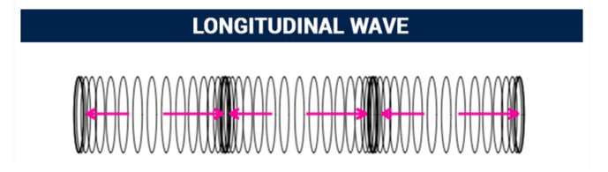
- Transverse waves - movement of the particles are at right angles (perpendicular) to the motion of the energy. Movement of a wave through a solid object like a stretched rope or a trampoline is an example of this type of wave.
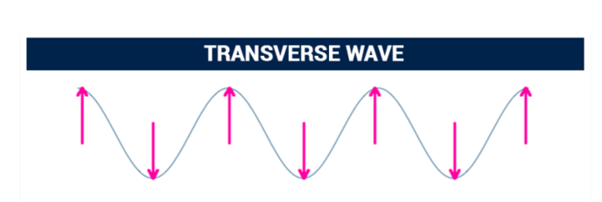
- Surface waves - particles travel in a circular motion. These waves occur at interfaces. Examples include waves in the ocean and ripples in a cup of water. One consequence of occurring at an interface is that the motion of the particles diminish with distance from the interface. The further from the interface the smaller the rotation of the particles until as some distance from the surface, there is no more movement or energy propagation.
FOURIER ANALYSIS
Many waveforms consist of
- energy at a fundamental frequency
- harmonic frequencies.
- the objective of Fourier analysis is to calculate coefficients up to the largest possible value of n .
- The greater the value of n (i.e, the more terms in the series whose coefficients can be determined), the more accurate is the Fourier-series representation of the waveform.
To find the Fourier parameters,
Integrate g over the period T to find c
c= $\frac{2}{T}\int_{0}^{T}{g(t)}dt$
Integrate of over the period to find n^{th} harmonic
$a_{n}$= $\frac{2}{T}\int_{0}^{T}{g(t)}dt$

$b_{n}$= $\frac{2}{T}\int_{0}^{T}{g(t)}dt$

Exercise
Find the Fourier parameter, given the periodic version of the ASCII 01100010

CHANNEL
- A channel is a path between a transmitter and receiver.
- This path may be logical and physical in nature or hard wired or wireless.
- The path provides a passage for the information or data from transmitter to receiver with certain amount of loss of information or data, which may be reproduced with other techniques.
Channel Characteristics
- Channel Noise is a slight background interference present on the channel or unwanted electrical or electromagnetic energy that carries no data or information on but interfaces with the information or data..
- Noise classification
  - external or internal noise based upon the sources.
  - External noise is generally picked up from electrical appliances, electrical transformers, the atmosphere, or on even from outer space. Normally this noise does not seriously hamper the performance. However there are a number of electrical appliances or heavy current machines in use, external noise can affect communications. It also impacts communication during severe thunderstorms.
- Channel Bandwidth:
  - the size of the range of frequencies that can be transmitted through a channel.
  - the volume of information per unit time that a computer, person or transmission medium can handle.
  - It is measured in Hertz
  - It is determines how fast data flows on a given transmission path.
- Channel Capacity: I
  - the amount of information per unit time handled by either a link or a node ( system element ).
  - The messages transmitted may be either similar or different.
  - It is usually measured in bits per second.
  - Channel Capacity, C is defined as ‘the maximum mutual information I(X; Y) in any single use of the channel, where the maximization is over all possible input probability distributions {p(x_{j})} on X

$$C=\max_{p(x_{j})}⁡I(X;Y)$$

C is measured in bits/channel-use, or bits/transmission.

- Maximum Data Rate
  - Max data rate is the highest rate in bps at which data is transmitted over commutation line with arbitrarily less error. Data rate depends on three factors:

- The bandwidth available
- The level of the signals we use
- The quality of the channel (the level of noise)

  - Two theoretical formulas were developed to calculate the data rate:
    - Nyquist for a noiseless channel

BitRate = 2 x bandwidth x log₂ L
        - bandwidth is the bandwidth of the channel,
        - L is the number of signal levels used to represent data,
        - BitRate is the bit rate in bits per second.

    - Shannon for a noisy channel
Capacity = bandwidth x log₂ (1 + SNR)

- bandwidth is the bandwidth of the channel,
- SNR is the signal-to-noise ratio, and
- capacity is the capacity of the channel in bits per second.

COMMUNICATION CHANNEL /MEDIA
- also transmission media called channel or transmission media.
- form of pathway
- Data or signal is exchange between two devices via some form of physical transmission medium such as a wired (guided) or logical connection such wireless (unguided).
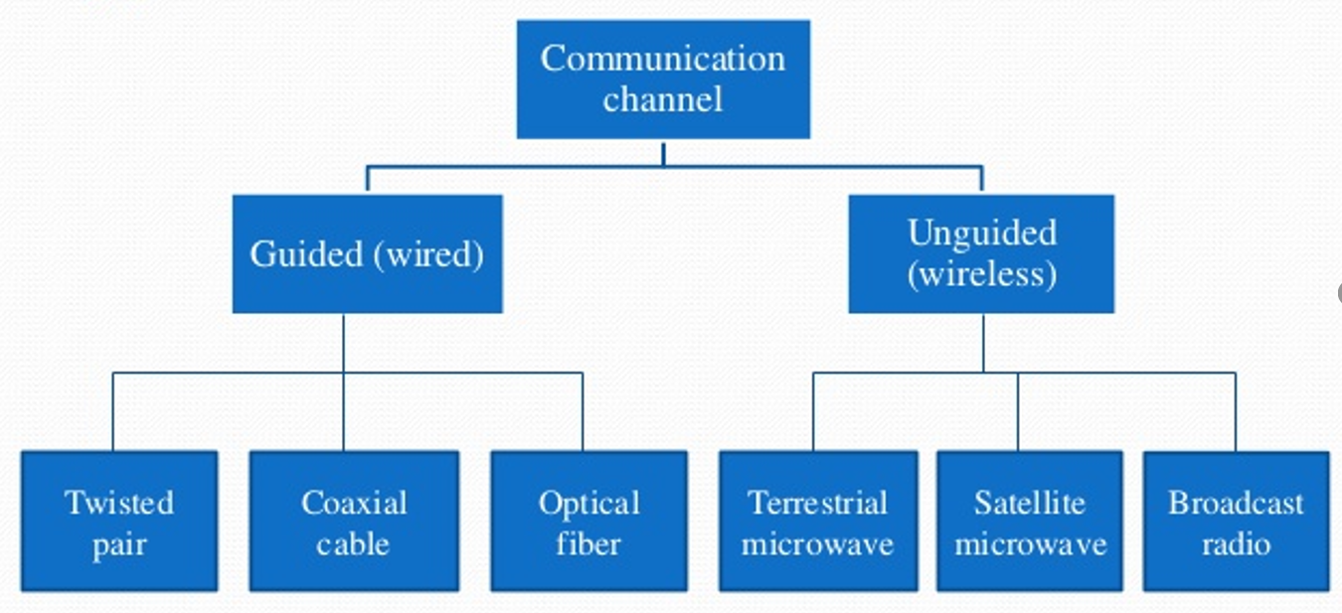

- Criteria which may affect the choice of communication media include:
  - (a) Cost, (b) Security, (c) Vulnerability, (d) Bandwidth, (e) Delay, (f) Accessibility / mobility, (g) Reliability, (h) Architecture - eg broadcast systems.

Data Communication characteristics
- Delivery. The system must deliver data to the correct destination. Data must be received by the intended device or user and only by that device or user.
- Accuracy. The system must deliver the data accurately. Data that have been altered in transmission and left uncorrected are unusable.
- Timeliness. The system must deliver data in a timely manner. Data delivered late are useless. In the case of video and audio, timely delivery means delivering data as they are produced, in the same order that they are produced, and without significant delay. This kind of delivery is called real-time transmission.
- Jitter. Jitter refers to the variation in the packet arrival time. It is the uneven delay in the delivery of audio or video packets. For example, let us assume that video packets are sent every 3D ms. If some of the packets arrive with 3D-ms delay and others with 4D-ms delay, an uneven quality in the video is the result.

Components of Data Communication

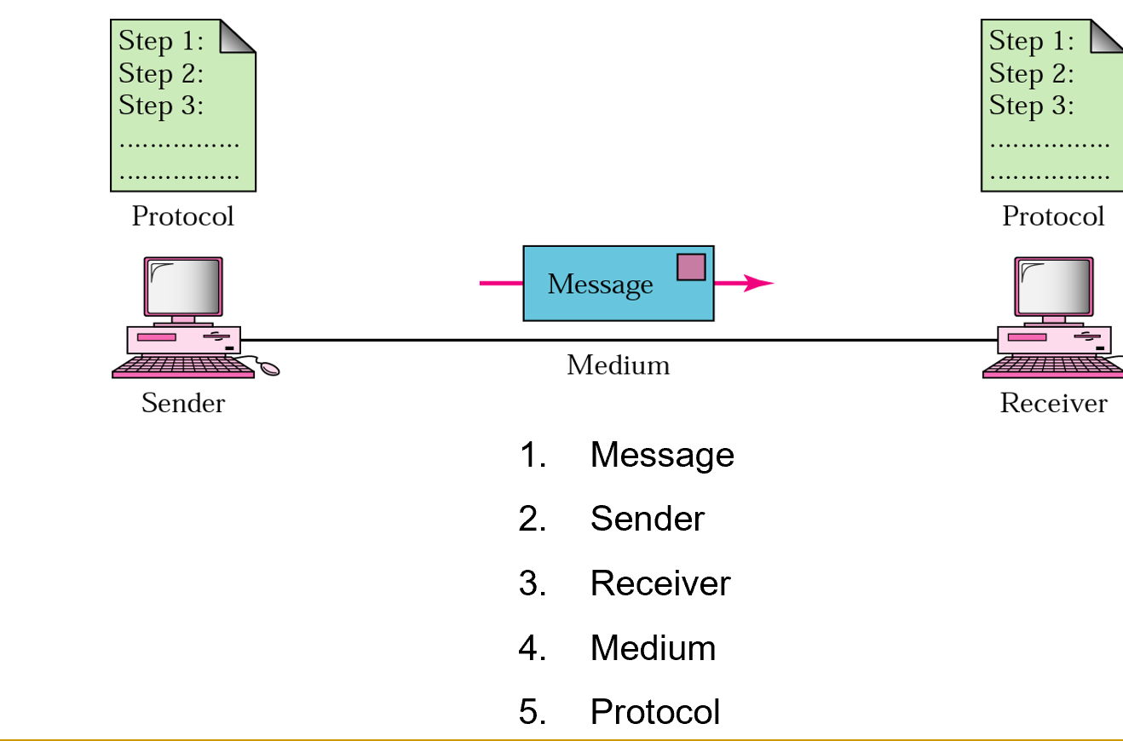

Transmission Impairment
- Transmission impairment deals with signals travel through transmission media, which are not perfect.
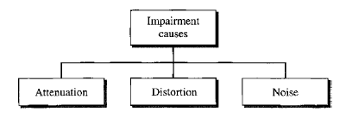

MODULATION.
- A process of changing the characteristics of the wave to be transmitted by superimposing the message signal on the hogh frequency signal
.

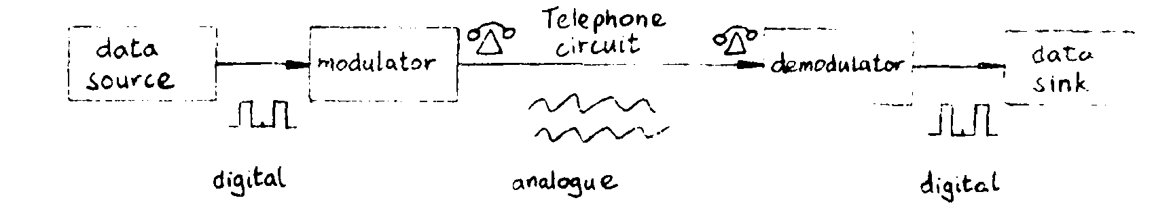
- The digital signals are converted into tones by the MODulator for transmission down the telephone line, and are then converted back to data by the DEModulator. Devices which perform both these functions are called MODEMS
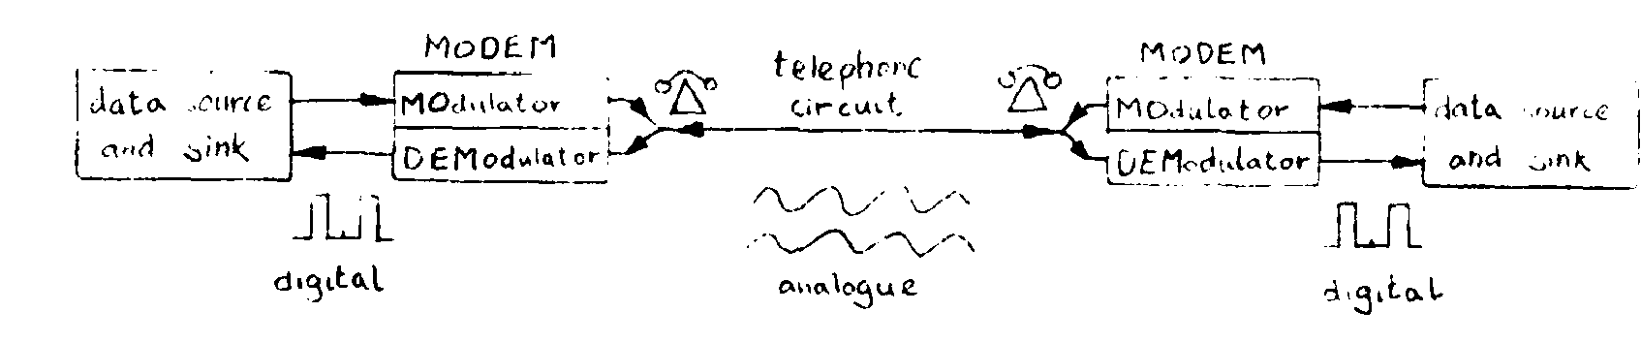
Modulation Techniques.
There are three basic kinds of modulation for converting digital signals to a form suitable for an analogue channel -
- AM Amplitude Modulation,
- FM Frequency Modulation,
- PM Phase Modulation.

MULTIPLEXING
- a technique by which different analog and digital streams of transmission can be simultaneously processed over a shared link.
- Multiplexing divides the high capacity medium into low capacity logical medium which is then shared by different streams.

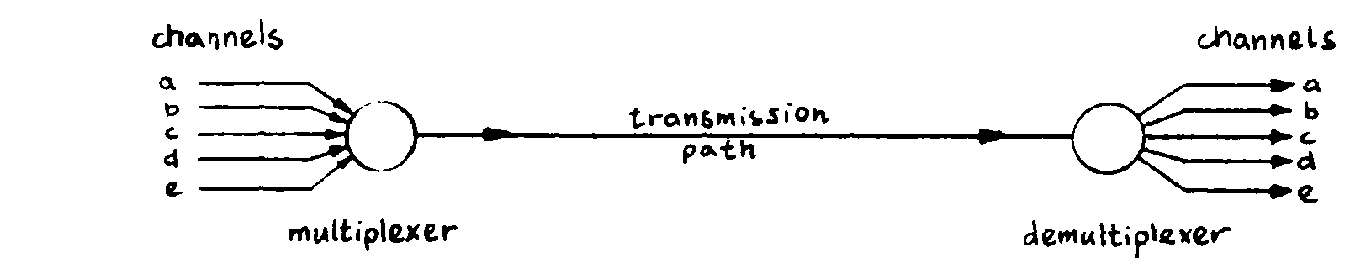

Techniques for multiplexing
- FDM Frequency Division Multiplexing,
- TDM Time Division Multiplexing,
- SDM Space Division Multiplexing,
- CDM Code Division Multiple
- WDM Wavelength Division Multiplexing

DATA TRANSMISSION MODE
- Data transmission refers to the process of transferring data between two or more digital devices.
- Data is transmitted from one device to another in analog or digital format.
Methods
- Serial Transmission: Serial data transmission sends data bits one after another over a single channel
Two classifications:
  - Asynchronous Serial Transmission
  - Synchronous Serial Transmission
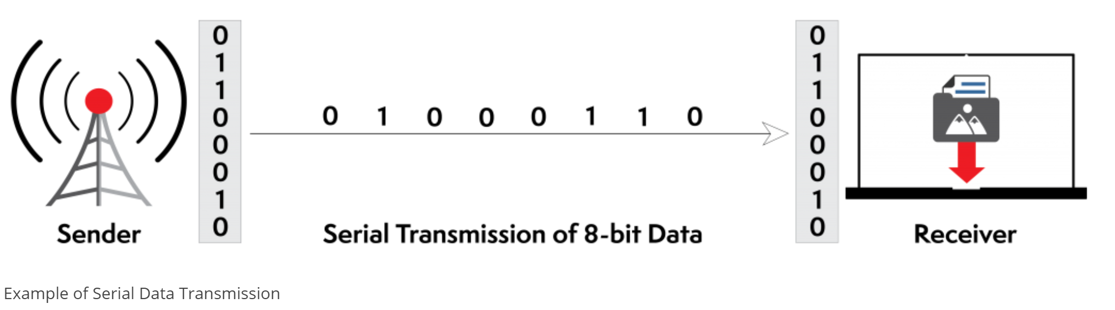
- Parallel transmission: Parallel data transmission sends multiple data bits at the same time over multiple channels.
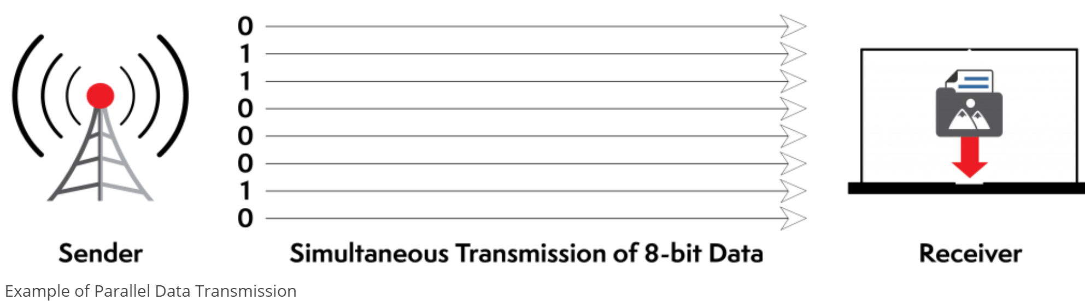
Parallel transmission is used when:
- a large amount of data is being sent;
- the data being sent is time-sensitive;
- the data needs to be sent quickly.

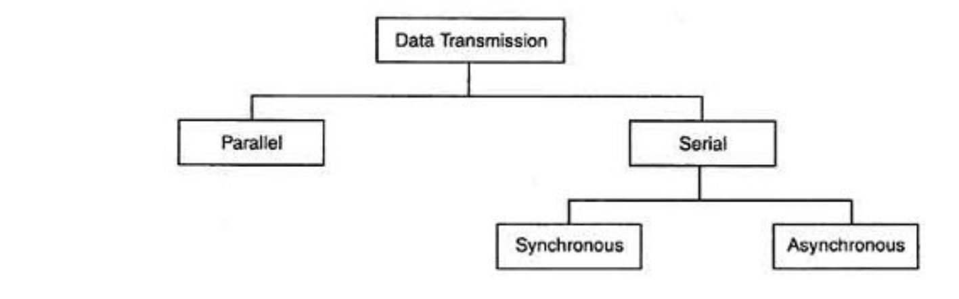
NETWORKS
- A network is a set of devices (often referred to as nodes) connected by communication links.
- A node can be a computer, printer, or any other device capable of sending and/or receiving data generated by other nodes on the network.

The hree primary categories
- Local-Area Networks,
- Metropolitan-Area Networks
- Wide-Area Networks. The category into which a network falls is determined by its size.

Network Models
- Communication networks are often broken into a series of layers, each of which can be defined separately, to enable vendors to develop software and hardware that can work can communicate with one another in the overall network.

The two best-known standards:
- the Open Systems Interconnection (OSI) model
- the Internet model.

The OSI
The OSI model defines a seven-layer network;
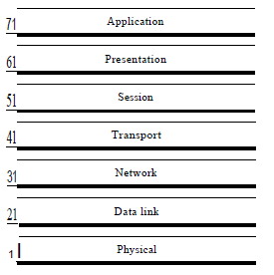

The Internet Layer
the Internet model defines a five-layer network.

- The application layer is the application software used by the network user.
- The transport layer takes the message generated by the application layer and, if necessary, breaks it into several smaller messages.
- The network layer addresses the message and determines its route through the network.
- The data link layer formats the message to indicate where it starts and ends, decides when to transmit it over the physical media, and detects and corrects any errors that occur in transmission.
- The physical layer is the physical connection between the sender and receiver, including the hardware devices (e.g., computers, terminals, and modems) and physical media (e.g., cables and satellites). Each layer, except the physical layer, adds a Protocol Data Unit (PDU) to the message.

SWITCHING
- Switching is process to forward packets coming in from one port to a port leading towards the destination.
- A switched network consists of a series of interlinked nodes, called switches.
- Switches are devices capable of creating temporary connections between two or more devices linked to the switch.
- In a switched network, some of these nodes are connected to the end systems

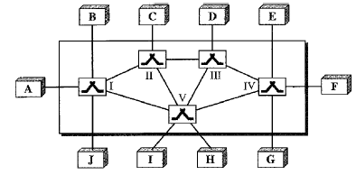

The three broad categories of Network switching

