Writing Mathematics on
Computer Programs

M.B.Abdullahi

©M.B.Abdullahi, 2012

ALL RIGHTS RESEARVED
No part of this publication may be reproduced or transmitted in any form or by any means, electronic or mechanical, including photocopying, recording or any information storage and retrieval system, without permission in writing from the Author.

ISBN: 978-125-939-6

Printed by Ahmadu Bello University Press Ltd; Zaria,
Kaduna State, Nigeria. Tel: 08065949711
Email:abupresslimited2005@yahoo.co.uk
Website: www.abupress.org

Dedication

This book is dedicated to my younger brothers: Ahmed, Al Amin, Abdulmumin and Abdullahi.

Preface
This book is written to infrastructure many Nigerian Typist, especially the ones that typed many secondary school mathematics textbooks as well as it showcases numerous examples in Visual and Liberty BASIC Programming Languages for interested readers, especially Gombe State Secondary Schools’ Typists.The book ostensively rekindles a lot of typographical errors widespread in many Nigerian Secondary Schools Mathematics Textbooks as well as it makes Visual and Liberty BASIC programming languages at finger tips of young mathematicians zealot in learning programming.
Ms Equation Editor and AutoCAD married to transform gloomy typographical errors in typing mathematics equations and graphing them.
Visual BASIC makes students design their own CGPA Calculator, Simple Calculator, Multiplication Table Machine, etc. and execute such soft devices on their window desktop. Technology depends on programming and programming depends on logic.Despite these programming languages are archaic, they still serve as a basic serious background to learning modern ones.
New Model Calculators: CGPA Calculator, Multiplication Table Machines, Algebraic Calculator, etc. were developed single-handedly , and 100% of programs presented in this book are original ideas, and cannot be found in any other book on the earth.
I tend to realized that 100% of Gombe State Secondary Schools do not use right medium in typing their mathematics question papers and thus creating maths phobia. The book inculcates basics for typing and graphing mathematics using right medium.
M.B.Abdullahi

Acknowledgement
Microsoft Corporation deserves a high level of recognition for designing Microsoft Windows for our peruse as well as the National Mathematical Centre, Abuja for its use of Library and for conducting its International Conference on Scientific Computing in 2011.
My warm extension of deep and profound gratitude goes to: Sen. Dnajuma Goje, the Rector: Jigawa State Polytechnic: Prof. G.U.Garba, the Commissioner for Education, Gombe State: Mrs Aisha Ahmed and the Honourable Commissioner for Higher Education: Dr. IsahMuhammadu Wade.I also have to record thanks to the following people: The VC of the Gombe State University: Prof. Ibrahim Umar(OON), the Registrar of the Federal University, Kashere: Dr. AbubakarAliyu Ba Feto, the Chiarman, Tinka Point, Gombe State: (Dr) Bala Bello Tinka, the Honourable Speaker of Gombe State: Alh. Inuwa Garba, the former Dean Faculty of Science, FUK, Gombe: Dr Mohammed SaniGumel and the Dean Faculty of Science, FUK, Gombe: Prof. M.B. Abdullahi and the SSG, Gombe State.
This book is singlehandedly written and typed based on practical experience in the realm by the author, but I appreciate my publisher and all sources referred to.

Table of Contents
Dedication…………………………………………………………………………………iii
Preface………………………………………………………………………………………iv
Acknowledgement………………………………………………………………………v
Table of Contents…………………………………………………………………………vi

1.0.Introduction……………………………………………………………………..1
1.1.Common Mathematical Errors………………………………………………1
Exercise 1…………………………………………………………………………………..6
1.2.Types of Computer Programming Error………………………………..7

2.0.Microsoft Equation Editor……………………………………………….8
2.1.OpeningMs Equation Editor Window……………………………………..8
2.2. Menus on Ms Equation Editor Tools……………………………………….8
2.3.Ms Equation Tools…………………………………………………………………10
2.4.How to create an Equation………………………………………………….19
2.5.How to Edit an Equation……………………………………………………19.
Exercise 2………………………………………………………………………………23

3.0. AutoCAD…………………………………………………………………………24
3.1.Stating AutoCAD…………………………………………………………………24
3.2.AutoCAD Window………………………………………………………………25
3.3.Specifying Coordinates……………………………………………………….25
3.4.Models………………………………………………………………………………26
3.4.1.Scaling Models………………………………………………………………..26
3.4.2.Paper Sizes…………………………………………………………………….26
3.4.3.Standard Scales in a Building………………………………………….26
3.5.Dash Board………………………………………………………………………27
3.6.How to Draw 2D Objects……………………………………………………27
3.7.How to draw 3D Objects……………………………………………………28
3.8.How to Reshape 3D Objects………………………………………………28
3.8.1.How to Rotate or Move 3D Objects……………………………….28
3.8.2.Combining Solids………………………………………………………….28
3.9.How to Print AutoCAD Document…………………………………….32
Exercise 3………………………………………………………………………………35

4.0.Visual BASIC Editor…………………………………………………………36
4.1.Opening Visual BASIC Editor Window…………………………………36
4.2.VB Editor Window .…………………………………………………………….37
4.3. Developing Applications……………….…………………………………….37
4.4.Modes of Applications………………………………………………………….38
4.5 Windows on VB Editor Window ……..……………………………………38
4.6.How to Put Controls on the Form…………………………….…………..39
4.7.How to Codes Controls………………………………………………………40
4.8.Operators……………………………………………………………………………..40
4.8.1 Arithmetic Operators………………………………………………………….40
4.8.2.Comparison Operators………………………………………………………..41
4.9.How to Make Form Executable on Your Deskto………………..41
Exercise 4……………………………………………………………………………….59

5.0.Liberty BASIC Programming Language……………………….61
5.1.Installing Liberty BASIC…………………………………………………….61
5.2.Starting Liberty BASIC………………………………………………………..62
5.3.Arithmetic Operators………………………………………………………..62
5.3.1.BODMAS………………………………………………………………………63
5.3.2.Comparison Operators……………………………………………………63
5.4.Functions………………………………………………………………………….64
5.5.Liberty BASIC Branching…………………………………………………..64
5.5.1.Forms of Branching Statements……………………………………..65
Exercise 5………………………………………………………………………………73

Answers to Exercises……………………………………………………………….74
References……………………………………………………………………………78
1.0.Introduction
Most of the Math Phobias and massive failures of students and so teachers in the Nation are consequences of lack of skilled typist to cater for typing mathematics question papers and O Level mathematics textbooks. I present a better medium for typing mathematics: The Equation Editor Window.
Also, it has been taking me a surprise that many secondary school students cannot write an error free program in any programming language. Visual BASIC and Liberty BASIC are written to inculcate basics and interest of programming to such students.
1.1.Common Mathematical Errors
[1]sin$θ$
The ‘s’ is not capital except when dealing with principal values or specific range of values of $θ$, as well as the ‘c’ in cosine, the ‘t’ in tangent, etc.
[2]$\log_{2}{x}$
The ‘l’ is small letter unless when you are referring to Laperian Log or Natural Log. The base is in smaller font size than the power.
[3]$\lim_{x→0}{}$is not the same as $\lim_{x→0}{}$. The later is an error.
[4]$x=\frac{2}{3}$
The dividing line should be in line with the equality, not $x\frac{=}{}\frac{2}{3}$or $x=2/3$.
[5]x = 2
This should be written as x = 2, with spacing between x and = and between = and 2.
[6] ${1001101}_{2}$
This should be written as ${1001101}_{two}$ in words not in numeral.
[7]$2x+3y=5……………………….(1)$
This should be written as $2x+3y=5…(1)$. This is an ellipsis and should not have more than 3 dots. But, you can have 3.5.7…..101, where the first and the last dots before and after the ellipsis are for products.
We can also write 1,2,3,4,….The last dot is for full stop.
[8] “etc.” , but not e.t.c.
[9]Proof:
This is correct as well as proof. Or Proof as a heading.
[10]To proof
This is wrong, but to prove is right. Proof is a noun and prove is a verb.
[11]Let p be price of commodity.
This is right seemingly, but it is better if it is: let p is a price of commodity.
[12] p = q
This reads as p equals q, not p equal q, Subject -Verb agreement.
[13]mathematics is right and Mathematics is wrong, but you can write Department of Mathematics.
[14]Math or Maths ?
Both math and maths is right. Math is American spelling and maths is British.
[15] $x=3y=4z=5k=60$
This is better written as $x=3y⟺x=4z=5z⟺$ x=60. “=” is a verb. You should not have many lexical verbs in a simple sentence.
[16] $\frac{x^{2}y^{3}}{x^{5}y^{2}}=\frac{y}{x^{3}}$
Differentiate cancelations of different variables.
[17] $\sqrt{\left(-1\right)(-1)}≠\sqrt{(-1)}\sqrt{(-1)}$
If $\sqrt{\left(-1\right)(-1)}=\sqrt{(-1)}\sqrt{(-1)}$ , then $1=\sqrt{(-1)}\sqrt{(-1)}=i^{2}=-1, i.e.1=-1, a contradiction.$
[18] Let 3>2. Then $3log\left(\frac{1}{2}\right)>2log\left(\frac{1}{2}\right)$
$$log{\left(\frac{1}{2}\right)}^{3}>log{\left(\frac{1}{2}\right)}^{2}$$
$$\frac{1}{8}>\frac{1}{4}$$
This is wrong because $log\left(\frac{1}{2}\right)$ is negative. Be mindful of multiplication with negative entities.
[19]
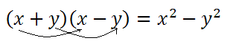
Generally, the use of arrows to showcase expansion or explain steps is better done using wordings. For example, expand the brackets.
[20]Make r the subject in $r+3p=q.$
Step: Subtract 3r from both sides of the equation, not transfer 3r to the other side.
[21] Both sides of an equation is better than writing both-sides or both sides of an equation.
[22] $x+3p=q$should be better written as $r+3p=q$ or $u+3w=v$or $i+3j=k.$
The use of letters close by in the English Alphabets is better.
[23] If h=3, i=6 is right as well as if h=3, then i=6 or if h=3 then i=6.
[24]Let $p={2q}^{2}$, then $q=\sqrt{\frac{p}{2}}$ is better written as: Let $p={2q}^{2}$. Then $q=\sqrt{\frac{p}{2}} .$
Let Statement is not a subordinate clause in mathematics.
[25]$\frac{a}{\frac{b}{c}}$is not the same as $\frac{\frac{a}{b}}{c}$. The former means fraction divides a whole number, but the later means a whole number divides a fraction.
[26]$P=\left\{x:x∈Nand 10≤x<30\right\}$should be better written as$P:=\left\{x:x∈Nand 10≤x<30\right\}$.
[27] $P=2q^{2}$. Where p = price is better written as $p=2q^{2}$, where p = price.
[28]$1+3×2≠8$, but $1+3×2=7$ using BODMAS.
[29]XXY is better written as X.Y.
[30]3.2 is better written as $3×2.$

Exercise 1: Common Mathematical Errors
Identify errors in the following:
[1]$3\sqrt{27}=3$
[2]$x-1\sqrt{x^{2}-1}=x+1$
[3]$\frac{16}{64}=\frac{16}{64}=\frac{1}{4}$
[4]$1^{0}=2^{0}⟹1=2$
[5]$\sin{100>\cos{10}0}$
$$⟹2\cos{100\sin{100}}>2\cos{100\cos{100}}$$
$$⟹\sin{}200>2\cos^{2}100$$
Hence, $-0.34>0.06,$ this is a contradiction.
1.2.Types of Computer Programming Errors
[1]Syntax Error
This is when you mistype a command or leave out an expected phrase or argument.
[2]Runtime Error
This is usually shown as a warning to you that the program is beyond the program control.
[3]Logical Error
This is when you run a program and get a wrong output.

2.0.Microsoft Equation Editor
This is a special version of the math type equation edition form. It is used in building complex equations by picking symbols from a toolbar and typing in variables and/or numbers. As you build an equation, equation editor automatically adjust font sizes, spacing and formatting to keep to mathematical conventions.

2.1.OpeningMs Equation Editor 3.0
To open Ms Word Document in 2003 Version;
[i]Click on Insert Menu;
[ii]Click on Object; and
[iii]Click on Ms Equation Edition 3.0.
You can open it directly by clicking Alt and then +.
In 2007 version, you find it on the toolbar.

2.2.Menus of Ms Equation Editor Window
Ms Equation Editor has 8 menus: File, Edit, View, Format, Style, Size, Window and Help.
(a)File
This comprises: New, Open, Close, Save as a Web Page, File Search, Page Set Up, Print Preview, Print, Sent to, Properties, Exit, etc.
(b)Edit
This comprises: Undo, Cut, Copy, Paste, Clear, Select All, etc.
(c)View
This comprises: 100%, 200%, 400%, Zoom, Toolbar, Redraw, Show All, etc.
(d)Format
This comprises: Align Left, Align Right, Align at =, Align Centre, Align at, Matrix Spacing, etc.
(e)Style
This comprises: Math, Text, Function, Various, Greek, Matrix-Vector, Other,…, Define, etc.
(g)Window
This comprises: New Window, Arrange All, Compare Side by Side with…, Split, Named Document.
(h)Help
This comprises: Equation Editor Help Topic and About Ms Equation Editor.

2.3.Ms Equation Tools
Before looking at tools, let us have an over view of Palette, Template and Fences.
(a)Palette
This is a group of related symbols and templates that appear when you click a button on the toolbar. A symbol is inserted into your equation when you click it on the Palette.
(b)Template
This is a collection of symbols and empty templates. You build expressions by inserting templates and filling in their slots.
You can create complex hierarchical formula by inserting templates into the slot of other templates.
(c)Fences
Fences provide various ways of enclosing expression between a matching pair of symbols. These include various brackets, parenthesis, etc.
There are about 150 mathematical symbols and about 120 templates.
[i]Toolbar Symbols and Templates for Ms Word 2003
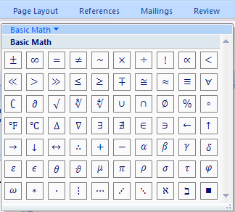
[ii]Toolbar Symbols and Templates for Ms Word 2007
1.Under Equation Options, click insert New Equation.
2.In the equation toolbar, click any tool as desired.
3.Click, the down arrow key, to select: Greek Letters, Basic Math, Letter-Like Symbols, Operators, Arrows, Negated Relations, Scripts and Geometry.
(a)Basic Math

(b)Greek Letters

(c)Letter Like Symbols

(d)Operators

(d)Arrows

(e)Negated Relations

(f)Scripts

(g)Geometry

2.4.How to Create an Equation
You built equation by picking templates and symbols from the toolbar and typing variable and/or numbers in the slots provided.
To nest a template within a template, select the templates you want to nest in the equation editor template.

2.5.How to Edit an Equation
1.Double click the equation;
2.Make necessary changes as desired;
3. Click outside the Equation Editor Object.
Examples
[1]Write ${(A∪B)}^{c}=A^{c}∩B^{c}$.
Solution: Click $([ ])$ and type A. Click $∪$ then type B. Click = and click ${[ ]}^{[ ]}$, then type A in the box that is the base and C in the box that is the superscript. Click $∩$ then click ${[ ]}^{[ ]}$ again. Click [ ] and type B. Click the superscript box and type C.

[2] Write $∼P∧∼q≡∼(P∨q)$.
Solution: Click $∼$. Type P. Click $∼$ and type q. Click $≡$ and click $∼$. Click it and type p. Click $∨and type q.$

[3]Write $\lim_{n→∞}{\frac{x}{\sqrt{x}}}$.
Solution: Click $\lim_{[ ]}{[ ]}$. Type $n→∞$ under. Click [ ] and click $\frac{[ ]}{[ ]}$. Click the numerator [ ] and type x and click the denominator box. Click $\sqrt{[ ]}$. Type x in the box.

[4]Write $\left(\begin{matrix}1 & 2 \\ 3 & 4\end{matrix}\right)$.
Solution: Click the box and click $\begin{matrix}[ ] & [ ] \\ [ ] & [ ]\end{matrix}$. Click the boxes one after the other to type 1, 2, 3 and 4. Highlight $\begin{matrix}1 & 2 \\ 3 & 4\end{matrix}$and click $\left(\right).$

[5]Write $\oint_{\sqrt{x}}^{x}{x^{2}dx}$.
Solution: Click $\oint_{[ ]}^{[ ]}{[ ]}$. Click the lower limit [ ] and click $\sqrt{[ ]}$, type x in it. Click the upper limit [ ] and type x. Click the empty box and click ${[ ]}^{[ ]}$. Type x in the box and 2 in the superscript. Then type dx.

[6]Write $x=\frac{-b±\sqrt{b^{2}-4ac}}{2a}$.
Solution: Type x and click =. Click $\frac{[ ]}{[ ]}$. Click the numerator [ ] and type –b. Click $±$ and click $\sqrt{[ ]}$. In the box, click ${[ ]}^{[ ]}$ and type b. In the superscript [ ] , type 2. Click – and type 4ac. Click the denominator and type 2a.

[7] Write $y={sinθ}^{sinθ}$.
Solution: Type y and click =. Click ${[ ]}^{[ ]}$. In the base [ ], type sin and click $θ$. Click the superscript and type sin then $θ$.
[8]Write $=tanθ+\sqrt{tanθ+\sqrt{tanθ+\sqrt{tanθ+…∞}}}$ .
Solution: Type$y=tanθ+$. Click $\sqrt{[ ]}$ and click [ ]. Click $\sqrt{[ ]}$ and click [ ]. Click $\sqrt{[ ]}$ and click [ ]. Click $\sqrt{[ ]}$ and click [ ]. Click $\sqrt{[ ]}$ and click [ ]. Type $tanθ+$ respectively. Click… and $∞$.

[9] Write $=x^{x^{.^{.^{.^{∞}}}}}$ .
Solution: Type y and click =. Click ${[ ]}^{[ ]}$ and type x in both the index and the base. Click ${[ ]}^{[ ]}$and type x in the index .Type x in the base.Click index [ ]. Click ${[ ]}^{[ ]}$ and click the base [ ]. Type x and click the index [ ]. Click ${[ ]}^{[ ]}$. Click the base [ ] and type x. In the index [ ], click….Click ${[ ]}^{[ ]}$ and click $∞$.

[10]Write $\frac{sinθ}{\frac{cosθ}{tanθ}}$.
Solution: Click $\frac{[ ]}{[ ]}$. Click the numerator [ ] and type $sinθ$. Click the denominator and click $\frac{[ ]}{[ ]}$. Type $cosθ and tanθ$ respectively.
Exercise 2: Equation Editor
[1]Write $S_{n}=\frac{n}{2}(2a+(n-1)d)$.
[2]Write $S_{n}=\frac{a(1-r^{n})}{1-r}$.
[3]Write $\frac{\frac{\sin{x}}{\cos{x}}}{\frac{\tan{x}}{\cot{x}}}$ .
[4]Write $max_{0≤x≤1}xe^{-x^{2}}.$
[5]Write $lim_{n→∞}{\left(1+\frac{1}{n}\right)}^{n}.$
[6]Write $x_{y^{2}.}$
[7]Write$\sin\left(∝+β\right)=\sin{α\cos{β+\cos{α\sin{β}.}}}$
[8]Write $θ\left(a⊕b\right)=θ(a)⊗θ(b)$.
[9]Write $∃x∈N, ∋x^{2}=1.$
[10]Write $f\left(x\right)=a_{0}+\sum_{n=1}^{∞}{\left(a_{n}\cos{\frac{nπx}{L}+b_{n}\sin{\frac{nπx}{L}}}\right)}$.

3.0 AutoCAD
CAD is an acronym of Computer Aided Design. AutoCAD can be used in designing not only architectural buildings, but (also) electronic and mechanical models.
It can also be used in drawing mathematical equations graphs and complicated mathematical drawings.

3.1.Starting AutoCAD
AutoCAD can be started from Desktop Shutcut or Auto Desk Sub Menu. When AutoCAD Window first opens, it displays a blank Drawing Area ready for you to start drawing.

3.2.AutoCAD Window
AutoCAD Window comprises:
(a)Drawing Area: This displays model space or paper scale layout.
(b)Command Line: This is used for entering coordinates.
(c)Status Bar: This includes Grid and Snap.
(i)Grid: This shows rectangular pattern of dots.
(ii)Snap: This makes the mouse jumps to the nearest snap point on clicking.

3.3.Specifying Coordinates
There are two coordinate systems as follows:
(1)Cartesian: This is of the form x, y, z;
(2)Polar: This is in the form of distance<angle.
Note: Angles are measured in anti clockwise direction.

Models
3.4.1.Scaling Model
Let 1000 by 500 Model be represented by 25 by 50 on A4 Size Paper. Then the $lengthscale=\frac{1000}{25}=40 and$
$$WidthScale=\frac{500}{50}=10$$
3.4.2.Paper Sizes
A1 ${24}^{''}×{36}^{''}$
A2 ${19}^{''}×{24}^{''}$
A3 ${12}^{''}×{18}^{''}$
A4 $9''×12''$

3.4.3.Standard Scale of a Building
[a]Roof Sloping =$15^{0}$
[b]Height=3100
[c]Windows=600 by 600 or 120 by 120
[d]Doors=900 by 2100 by 50
[e]Ground Floor = 100 by 50

3.5.Dash Board
This is where tools assemble for drawing 2D and 3D objects very easily.
To get into the Dash Board, you:
(1)Click on tools menu of AutoCAD 2004;
(2)On the options, click on palettes;
(3)On the palettes, click on Dash Board.

3.6.How to Draw 2D Objects
The Steps:
(1)Ensure that your snap is on;
(2)Set perpendicular, intersection, etc. on the object snap;
(3)Use drawing menu to draw your lines.

3.7 How to Draw 3D Objects
AutoCAD has three different 3 – Dimensional Drawing Modes. They are: Wire Frame, Surface and Solid. All that you need for this drawing is the Dash Board.

3.8.Rotate or Move 3D Objects
The Steps:
(1)Click on the solid to select it;
(2)Make sure that the object snap and polar are turned on;
(3)Right click select object;
(4)Highlight rotate or move as desired;
(5)Rotate or move the object manually.

3.8.2.Combining Solids
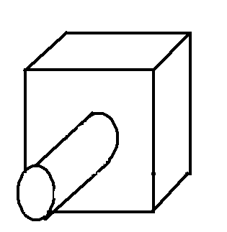
If two or more solids overlap as in the above, they can be combined to create a single shape.The following tools are used for this.
(a)Union: It joins solid shapes together.
(b)Subtraction: It removes overlapping volume of one solid from another.
(c)Intersection: It removes the solids with the exception of the overlap. The intersectant is the overlap.
(a)Uniting Solid Shapes
When two solids a cylinder and a cube, say, overlap as in the above;
(i)Click Union Tool on the Dash Board;
(ii) Hold Shift Key and click the solids to be united;
(iii)Right click to unite the solids.

(b)Subtraction
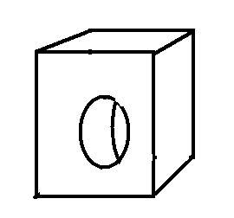
To subtract the cylinder from the cube, follow the following steps.
(i)Click subtract on the Dash Board;
(ii)Select the solid from which you want to subtract;
(iii)Select the solid to be subtracted from;
(iv)Right clicking finishes the task.

(c)Intersection
To find the intersection of the above overlapping objects, follow the following steps:
(i)Click intersection on the Dash Board;
(ii)Select the two solids;
(iii)Right click to finish the task.

3.9.How to Print AutoCAD Document
(i)Click File Menu;
(ii)Click Plot;
(iii)Choose Printer;
(iv)Select Plot to Limit;
(v)Click Apply Layout;
(vi)Click OK;
(vii)Click “Save after Naming” ;
(viii)Wait for plot to generate sheet;
(ix)Click Page;
(x)Click Rotate Page as desired;
(xi)Click Annotations;
(xii)Click Pen, Highlighter, etc. as desired;
(xiii)Click OK.

Examples
Follow the following steps to construct a door or a window.
(i)Make 2 cylinders overlap as shown below:
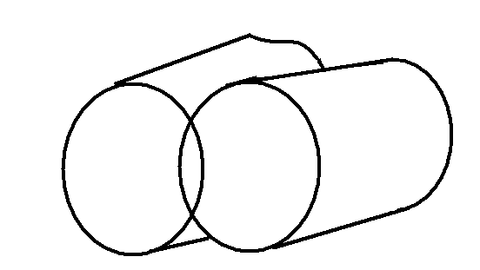
(ii)Use intersection tool so that it looks as follows:
(iii)Draw a box below it and unite.
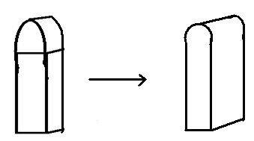
(iv)Use move to take the door or window to the building block.
(v)Subtract the door or window from the building block and use rendering to finish the work.

Exercise 3: AutoCAD
(1)Draw sinusoidal graph.
(2)Draw a parabola.
(3)Model a well structured house.
(4)Construct angle 16$5^{0}$, 7$5^{0}$and locus of a point, etc.

4.0.Visual BASIC Editor
Visual BASIC is a tool that allows you to develop Graphic User Interface before you write codes, which you could finally run.

4.1.Opening VB Editor Window
(1)Click on Tool Menu of Ms Word 2003;
(2)Click on Macro;
(3) Click on VB Editor;

In Ms Word 2007, you open it as follows:
(1)Click office Button;
(2)Click Word Options;
(3)On top options for working with word, click show Developer Tab in the Ribbon;
(4) On the Tool Menu, click Developer;
(5)Click VB Editor; and
(6)Click Insert and click user form.

4.2. VB Editor Window
VB Editor Window comprises:
(1)Form: This is the user interface.
(2)Controls: This is the graphical features drawn on the form such as: Textbox, Label, Command Button, etc.
(3)Properties:Every control has its properties window in which you can change its Name, Background Colour, Back Style, Border Colour, Border Style, Caption, Font Style, etc.

4.3.Developing Application
(1)Draw user interface;
(2)Assign properties to controls;
(3)Attach code to controls;
(4)Run the codes.

4.4.Modes of Application
(a)Design Mode: This is used in building application.
(b)Run Mode: This is used in running application.
(c)Break Mode: This is used in Debugging or Correcting Application.

4.5.Windows on VB Editor Window
(1)Main Window: This comprises Title Bar, Menu Bar and Tool Bar.
(2)Form Window: This is central to developing VB Applications.
(3)Tool Box Window: This consist of controls used in designing applications.
(4)Properties Window: This is used in changing the properties of a control.
(5)Form Layout Window: This is where programs are executed.
(6)Project Window: This is where you obtain a view of the form, list of all forms, code window, etc.
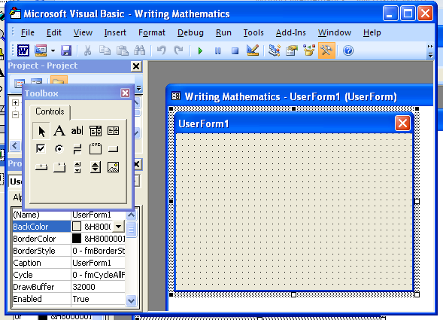
4.6.How to Put Controls on the Form
(1)Click the tool on the Tool Box;
(2)Move the mouse pointer to the form window;
(3)Use drag tool to generate it.

4.7.How to Code Controls
VB Editor provides the Private Sub Line and the End Sub Statement by double clicking a control. You only need to assign duty to the control through writing codes in between the two statements. Then Run the code.

4.8.Operators
4.8.1.Arithmetic Operators
Operator Operation
$^$Exponentiation
‘*’ Multiplication
+ Addition
/ Division
‘-‘ Subtraction

4.8.2.Comparison Operators
Operator Operation
‘>’ Greater Than
‘<’ Less Than
‘>=’ Greater Than or equal To
‘<=” Less Than or Equal To

4.9.How to Make Form Executable on Your Desktop
(1)Open the Form;
(2)Click File Menu;
(3)Click Executable;
(4)Click Desktop in the options;
(5)Wait for few seconds for the task to be complete.

Examples
(1)Write a program that will find volumes of cylinder $πr^{2}h.$
Solution:
(a)Graphic User Interface
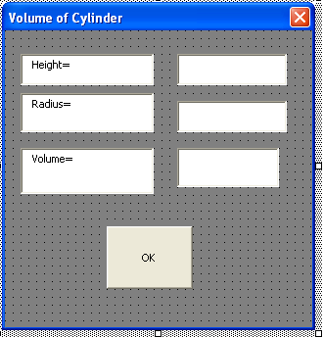
Double clicking OK will open:
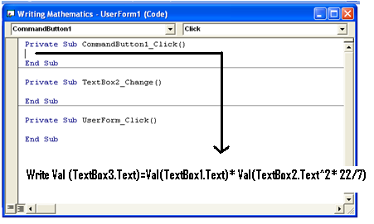
Run the Code as in the above.

(2)Write a VB Program that could compute compound interest $I=P{\left(1+\frac{R}{100}\right)}^{T}$, where P = principal, R = rate and T = time.
Solution: Graphic User Interface
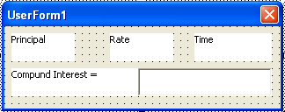
Code
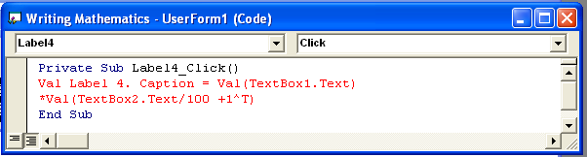
(3)Write a programming that computes GPA in VB Editor Programming Language.
Solution: Graphic User Interface
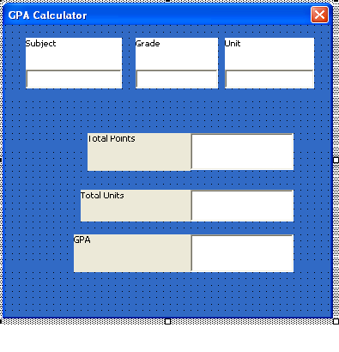

Code
Private Sub Command Button 1_Click()
Select Case TextBox2.Text
Case is = “A”
TextBox2.Text=5
Case is = “B”
TextBox 2.Text=4
Case is = “C”
TextBox2.Text=3
Case is = “D”
TextBox2.Text=2
Case is = “E”
TextBox2.Text=1
Case is = “F”
TextBox2.Text=0
End Select
End Sub
Private Sub Command Button 2_Click()
Label1.Caption=TextBox2.Text $
End Sub
Private Sub Command Button 3_Click()
Label2.Caption = Val (Label2.Caption)+Val(Val(TextBox2.Text)*Val(TextBox3.Text))
End Sub
Private Sub Command Button 3_Click()
Label4.Caption = Val Val(Label2.Caption)/Val(Label3.Caption))
End Sub

(4)Write a Program that Works Like an Algebraic Calculator
Solution: Graphic User Interface
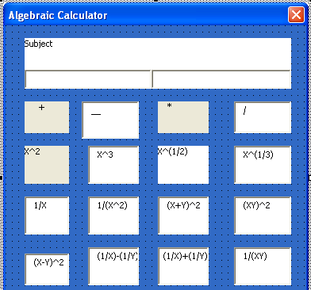
Code
Private Sub Command Button 1_Click()
Label1.Caption=Val(TextBox1.Text)+Val(Textbox2.Text)
End Sub
Label1.Caption=Val(TextBox1.Text^2)
End Sub
Private Sub Command Button 3_Click()
Label1.Caption=Val(TextBox1.Text^-1)
End Sub
Private Sub Command Button 4_Click()
Label1.Caption=Val(TextBox1.Text)-Val((Textbox2.Text)^2)
End Sub
Private Sub Command Button 5_Click()
Label1.Caption=Val(TextBox1.Text)*Val(Textbox2.Text)
End Sub
Private Sub Command Button 6_Click()
Label1.Caption=Val(TextBox1.Text^0.5)
End Sub
Private Sub Command Button 7_Click()
Label1.Caption=Val(TextBox1.Text)+Val(Textbox2.Text)
End Sub
Private Sub Command Button 7_Click()
Label1.Caption=Val(TextBox1.Text)+Val((Textbox2.Text)^2)
End Sub
Private Sub Command Button 8_Click()
Label1.Caption=Val(TextBox1.Text)-Val(Textbox2.Text)
End Sub
Private Sub Command Button 9_Click()
Label1.Caption=Val(TextBox1.Text^3)
End Sub
Private Sub Command Button 10_Click()
Label1.Caption=Val(TextBox1.Text^-2)
End Sub
Private Sub Command Button 11_Click()
Label1.Caption=Val(TextBox1.Text^-1)-Val(Textbox2.Text^-1)
End Sub
Private Sub Command Button 12_Click()
Label1.Caption=Val(TextBox1.Text^-1)+Val(Textbox2.Text^-1)
End Sub
Private Sub Command Button 13_Click()
Label1.Caption=Val(Val(TextBox1.Text)/Val(Textbox2.Text))
End Sub
Private Sub Command Button 14_Click()
Label1.Caption=Val(TextBox1.Text^(1/3))
End Sub
Private Sub Command Button 15_Click()
Label1.Caption=Val(TextBox1.Text^2)+Val(Textbox2.Text^2)
End Sub
Private Sub Command Button 16_Click()
Label1.Caption=Val(TextBox1.Text)+Val(Textbox2.Text)
End Sub
Private Sub Command Button 17_Click()
Label1.Caption=Val(TextBox1.Text^-1)+Val(Textbox2.Text^-1)
End Sub

(5)Design a Simple Calculator using simple codes in VB Editor Programming Language.
Solution: Graphic User Interface
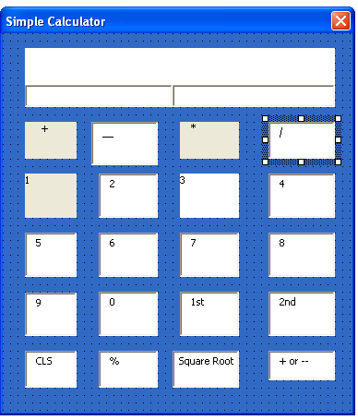
Code
Private Sub Command Button 1_Click()
Label1.Caption=Val(TextBox1.Text$)+Val(Textbox2.Text)
End Sub
Private Sub Command Button 2_Click()
Label1.Caption=Val(TextBox1.Text$)-Val(Textbox2.Text)
End Sub
Private Sub Command Button 3_Click()
Label1.Caption=Val(TextBox1.Text)*Val(Textbox2.Text)
End Sub
Private Sub Command Button 4_Click()
Label1.Caption=Val(TextBox1.Text)/Val(Textbox2.Text)
End Sub
Private Sub Command Button 5_Click()
Label1.Caption=Val(TextBox1.Text^0.5)
End Sub
Private Sub Command Button 6_Click()
Label1.Caption=Val(TextBox1.Text^2)
End Sub
Private Sub Command Button 7_Click()
Label1.Caption=Val(TextBox1.Text$)+Command Button 8.Caption
End Sub
Private Sub Command Button 9_Click()
Label1.Caption=Val(Label1.Caption$)+CommandButton9.Caption
End Sub
Private Sub Command Button 10_Click()
Label1.Caption=Val(Label1.Caption$)+CommandButton10.Caption
End Sub
Private Sub Command Button 11_Click()
Label1.Caption=Val(Label1.Caption$)+CommandButton11.Caption
End Sub
Private Sub Command Button 12_Click()
Label1.Caption=Val(Label1.Caption$)+CommandButton12.Caption
End Sub
Private Sub Command Button 13_Click()
Label1.Caption=Val(Label1.Caption$)+CommandButton13.Caption
End Sub
Private Sub Command Button 14_Click()
Label1.Caption=Val(Label1.Caption$)+CommandButton14.Caption
End Sub
Private Sub Command Button 15_Click()
Label1.Caption=Val(Label1.Caption)
End Sub
Private Sub Command Button 16_Click()
TexBox2.Text$=Val(Label1.Caption)
End Sub

Private Sub Command Button 17_Click()
Label1.Caption=Val(Textbox1.Text$/100)
End Sub
Private Sub Command Button 18_Click()
Label1.Caption$=Val(Label1.Caption$-1)
End Sub
Private Sub Command Button 19_Click()
Label1.Caption=Val(Label1.Caption$)+CommandButton19.Caption
End Sub
Private Sub Command Button 20_Click()
Label1.Caption=Val(Label1.Caption$)+CommandButton20.Caption
End Sub

(6)Write a VB Editor Program that computes Roots of Quadratic Equations.
Solution: Graphic User Interface
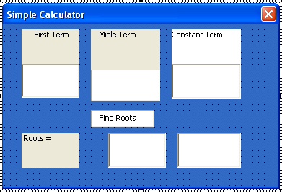
Code
Private Sub Command Button 1_Click()
Label1.Caption=Val(Textbox2.Text*-1)+Val(Textbox2.Text^2)-Val(Textbox3.Text*4))^0.5)/Val(Textbox1.Text*2))
Label1.Caption$=Val(Val(Textbox2.Text*-1)-Val(Textbox2.Text^2)-Val(Textbox3.Text*4))^0.5)/(Val(Textbox1.Text*2))
End Sub

(7)Write a program that works like Multiplication Machine.
Solution: Graphic User Interface
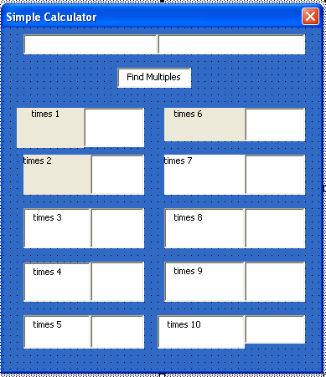
The Codes
Private Sub Command Button 1_Click()
Label1.Caption$=Val(Textbox1.Text$*1)
Label1.Caption$=Val(Textbox1.Text$*2)
Label1.Caption$=Val(Textbox1.Text$*3)
Label1.Caption$=Val(Textbox1.Text$*4)
Label1.Caption$=Val(Textbox1.Text$*5)
Label1.Caption$=Val(Textbox1.Text$*6)
Label1.Caption$=Val(Textbox1.Text$*7)
Label1.Caption$=Val(Textbox1.Text$*8)
Label1.Caption$=Val(Textbox1.Text$*9)
Label1.Caption$=Val(Textbox1.Text$*10)
End Sub
Exercises 4: VB Editor
Convert the following formula into VB Editor Code taking the subject as label and other parameters as Textboxes.
(1)$S_{n}=\frac{n}{2}\left(a+l\right)$(2)$P=2πr$(3)$D=\sqrt{b^{2}-4ac}$ (4)$T=πr^{2}l+πr^{2}h$(5)$S_{n}=\frac{a(1-r^{n})}{1-r}$(6)$a^{2}=b^{2}+c^{2}$
5.0.Liberty BASIC Programming Language
BASIC means Beginners All Purpose Symbolic Instruction Code.It was developed in 1960 as an easy to learn programming language for Computers.
Liberty BASIC is the easiest programming language around since 1992. McGraw Hill and Zipp Davis featured it.
It comprises a powerful BASIC language for windows and Visual Development Tool Free Form.

5.1. Installing Liberty BASIC
(1)Put the compiler into the dick drive;
(2)Click my computer;
(3)Click the disk name;
(4)Wait for installation to finish;
(5)Click OK.

5.2.Starting Liberty BASIC
(1)Click start menu;
(2)Click programs; and
(3)Click Liberty BASIC 3.0.

5.3.Arithmetic Operators
Operator Operation
+ Addition
‘-‘ Subtraction
‘*’ Multiplication
/ Division
^ Exponentiation

Note: Liberty BASIC supports scientific notation in code. For example, print $1.2334e^{-4}$.

5.3.1.BODMAS
Liberty BASIC works with this order.
() …Expression within parenthesis are evaluated first.
^ …Exponentiation are evaluated next
/…Followed by Division
Followed by Multiplication *
Followed by Addition +
Followed by Subtraction –

5.3.3.Comparison Operation
Operator Operation
‘>’ Greater Than
‘<’ Less Than
‘>=’ Greater Than or Equal To
‘<’ Less Than or Equal To
‘<>’ Not Equal To
5.3.3.Functions
Function Output
ABS Absolute Value
COS cosine
Date$ Current date as a string
Now Current time and date
SIN sine
SQR square root
Time$ Current time
HexDec Hexadecimal base
Log Logarithm

5.4.Liberty BASIC Branching
This is usually conditional statement. It causes certain action to occur if certain condition is achieved.

5.5.1.Forms of Branching Statement
(1)IF…THEN…STATEMENT
E.G.IF X-Y<0 THEN PRINT “NEGATIVE”

(2)IF…THEN …ELSE STATEMENT
E.G.IF X-Y<0 THEN PRINT “NEGATIVE” ELSE “POSITIVE”

(3)GOTO STATEMENT
E.g.
Line 10
Line 20
Line 30
Line 40
GOTO Line 10 or GOTO 10

Examples of Liberty BASIC Programs
(1)
10 CLS’ VOLUME OF CONE
20INPUT PIE, R, H
30 LET V=(1/3)*PIE*R^2*H
40 PRINT “VOLUME=”; V, “C$M^{3}$
(2)
10CLS’ AMOUNT OF COMPOUND INTEREST
20 INPUT P, R, T
30 LET A=P*(1+R/100)^T
40 PRINT “AMOUNT=”;A
50 GOTO 20
(3)
100 CLS’ COUNTING 1 TO 20
200 K=1
300 PRINT K
400 K=K+1
500 PRINT K
600 IF K<=20 THEN 400
700 PRINT K
800 END
(4)
100 CLS’TIME &DATE
200 PRINT DATE$()
300 PRINT TIME$()
400 END
(5)
1 CLS’ COMPLEX NUMBERS
2 INPUT A
3 IF A<0 THEN 7
4 LET D=A^0.5
5 PRINT D
6 GOTO 10
7 LET A=0-A
8LET Y=A^0.5
9PRINT “0+”; Y; “i”
10 END
(6)
1 CLS’MULTIPLICATION TABLE
2 INPUT C
3 PRINT “C=”; C
4 PRINT “C$×$2=”;C*2
5 PRINT “C$×$3=”;C*3
6PRINT “C$×$4=”;C*4
7PRINT “C$×$5=”;C*5
8PRINT “C$×$6=”;C*6
9PRINT “C$×$7=”;C*7
10PRINT “C$×$8=”;C*8
11 PRINT “C$×$9=”;C*9
12 PRINT “C$×$10=”;C*10
13 PRINT “C$×$11=”;C*11
14PRINT “C$×1$2=”;C*12
15 PRINT “C$×13$=”;C*13
16 PRINT “C$×$14=”;C*14
17 PRINT “C$×$15=”;C*15
18 PRINT “C$×$16=”;C*16
19 PRINT “C$×$17=”;C*17
20 GOTO 2
(7)
1 CLS ‘QUADRATIC ROOTS
2 INPUT A, B, C
3 LET D=B^2-4*A*C
4 IF D=0 GOTO 5 ELSE 7
5 LET X=(0-B)/(2*A)
6 PRINT “X=”; X; “TWICE”
7 GOTO 13
8 IF D>0 GOTO 8 ELSE 12
9 LET Y=(0-B+D^0.5)/(2*A)
10 LET Y=(0-B-D^0.5)/(2*A)
11 PRINT “Y=”; Y; “Z=”; Z
12 GOTO 13
13 LET F=0-D
14 LET R=0-B/(2*A)
15 LET G=(F^0.5)/(2*A)
16 PRINT “X=”; R; “IMAGINARY=”; G
17 GOTO 2
(8)
1 CLS ‘SOLUTIONS OF SIMULTANEOUS EQUATIONS
2 PRINT “INPUT THE SET OF 1ST CONSTANTS”
3 INPUT A, B, C
4 PRINT “INPUT THE SET OF 2ND CONSTANTS”
5 INPUT S, T, U
6 IF A<0, S<0 GOTO 7 ELSE 12
7 LET L=(B/A)-(T/S)
8 LET M=(C/A)-(U/S)
9 LET N=(M/L)
10 LET W=(3-B*N)/A
11 PRINT “X=”; W “Y=”; N
12 IF A<0, S<0 GOTO 13 ELSE 18
13 LET K=(B/A)+(T/S)
14 LET Q=(C/A)+(U/S)
15 LET Y=(Q/K)
16 LET X=(C-B*Y)/A
17 PRINT “X=”; X, “Y=”; Y
18 IF A>0, S<0 GOTO 13 ELSE 19
19 GOTO 2
(9)
1 CLS ‘SIMPLE CALCULATOR
2 INPUT A, C$, B
3 IF C$= “+” THEN 4 ELSE 7
4 LET Q=A+B
5 PRINT “A+B=”; Q
6 GOTO 2
7 IF C$= “*” GOTO 8 ELSE 11
8 LET W=A*B
9 PRINT “A*B=”;W
10 GOTO 2
11 IF C$= “/” GOTO 12 ELSE 15
12 LET E=A/B
13 PRINT “A/B=”; E
14 GOTO 2
15 IF C$= “-“ GOTO 16 ELSE 19
16 LET R=A-B
17 PRINT “A-B=”;R
18 GOTO 2
19 PRINT “USE SIMPLE OPERATION”
20 END

Exercise 5: Liberty BASIC
- $B=A\sqrt[3]{(1+3A^{2})}$
- $C=\left(\sqrt{\frac{1}{B}+{(\sqrt{B})}^{\frac{1}{5}}}\right){\left(\frac{1}{B}+{\sqrt{B}}^{\frac{1}{5}}\right)}^{7}$
- $H=\frac{A+B+C+D}{E}$
- $D={(1+\frac{1}{C}+\frac{1}{C^{2}}+\frac{1}{C^{3}})}^{3}$
- $F=\frac{D}{\left(1+\frac{2}{\sqrt{D}}\right)D+\left(\frac{1}{D}\right)}$
- $K=HIJ^{\frac{E}{C}}$

ANSWERS TO EXERCISES
Exercise 1: Common Mathematical Errors
(1)$3\sqrt{27}≠\sqrt[3]{27}$ (2)Long Division is not (3)You cannot cancel directly despite the answer is correct (4)You don’t cancel index zero (5) cos$100^{0}$ is negative, the sign should change to <.
Exercise 2: Equation Editor
(1)Click ${[ ]}_{[ ]}$ and type S, then n. Click = .Click $\frac{[ ]}{[ ]}$ and type n and 2.Click ([ ]) . In the box, type 2a+(n-1)d.
(2) Click ${[ ]}_{[ ]}$ and type $S_{n}$. Click $\frac{[ ]}{[ ]}$. In the numerator box, type a(1-and click ${[ ]}^{[ ]}$) and type r and n respectively. In the denominator box, type 1-r.
(3) Click $\frac{[ ]}{[ ]}$. In the denominator box, click $\frac{[ ]}{[ ]}$. Type sin x , cos x , tan x and cot x respectively.
(4)You can get it in the equation editor directly.
(5)You can get it in the equation editor directly.
(6) You can get it in the equation editor directly.
(7)Type sin and click ([ ]). Click $∝$+ $β$ in the box. Click = and type sin. Click $∝$ and type cos. Click $β+$ and type cos. Click and type sin. Click $β$.
(8)Click $θ$ and then ([ ]). Type a and b, then click $⊕$ in between. Click = and click $θ$, then ([ ]). Type b.
(9)Click $∃$ and type x. Click $∋$and ${[ ]}^{[ ]}$. Type x and 2. Click = 1 and click $∀$. Type x and click $∈$. Click $N$.
(10)You can get it in the equation editor directly.
Exercise 3: AutoCAD
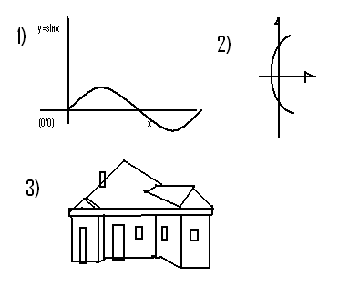

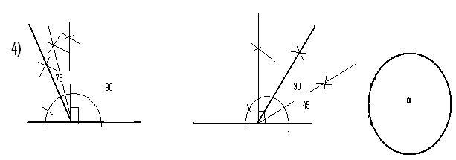
Exercise 4: VB Editor
- Label1.Caption=Val(Textbox1.Text/2)*Val(Val(Textbox2.Text)+Val(Textbox3.Text)
- Label1.Caption=Val(Textbox1.Text*22)*Val(Textbox2.Text*22/7)
- Label1.Caption=Val(Textbox1.Text^2)-Val(Textbox2.Text*4)*Val(Textbox3.Text)*Val(Textbox4.Text)))^0.5
- Label1.Caption=Val(Textbox1.Text^2)*Val(Textbox2.Text*(22/7))+Val(Textbox1.Text^2)*Val(Textbox3.Text*(22/7))
- Label1.Caption=Val(Val(Textbox1.Text)*(1-Val(Textbox2.Text^Val(Textbox 3.Text)))/(1-+Val(Textbox2.Text)
- Val(Textbox1.Text^2)=Val(Textbox2.Text^2)+Val(Textbox3.Text ^2)

References
AutoCAD 2004 Help Menu.
Alexander Shen(2008). Algorithm and Programming.Birkhauser, Boston, Basel, Berlin.
Microsoft Equation Editor Help Menu. Microsoft Corporation, U.S.A.
Liberty BASIC Help Menu.McGraw Hill and Zipp Davis.

J.H.Gallier(1987).Logic for Computer Science.John Wiley and Sons, Inc.
J.P.Killingbeck(1991).Micro Computer Algorithms. Published under Adam Hilter, Bristol 6NX, England.
W.J.Orvis(1992). Do it Yourself Visual BASIC. SAMS, U.S.A, 1st and 2nd Prints.
W.E.Tiley(1992). Tricks of the Window 3.1 Masters. SAMS, a Division of Prentice Hall Computer Publishing, Idiana. 1st Edition.

ABOUT THE BOOK
Typographical errors are widespread in many secondary school’s mathematics textbooks and question papers. The book guides typist/readers to writing mathematics in its best environment, Ms Equation Editor Windows.
Negligence in programming languages make our education a mere piracy. By piracy, I mean you ask yourself: What concrete objects can you showcase as an output of your education?
The book combines drawings and arithmetics to designing models for concrete objects viz: Calculator, Wristwatch, etc. in VB Programming Language.
With this introduction, secondary school students, students alike and non students alike will break status quo in designing beyond calculators, wristwatches, handsets, etc.

